

Letters | 1 – 5
Carla Piette Nomination | 5 - 6
Bazaar | 6 - 8
CLT Installation | 8
2015 Reunion Information | 9
Prayer Corner | 9 - 10
Bon Mot Corner | 10
Maryknoll Contemplative Community | 10 - 13
Philosophy Corner | 13 - 15
Poetry Corner | 15 - 16
Blogs/Diaries | 16 - 21
Favorite Recipes | 22 - 23
Kateri’s Corner | 23
Transitions | 23 - 30
Mission Institute | 31
Save the Dates | 32
Committee Information | 32
Subscription Form* | Last page

- WE ASK ALL WHO RECEIVE THE NEWSLETTER TO RETURN THE SUBSCRIPTION FORM ON THE LAST PAGE IN ORDER TO KEEP OUR DATABASE UP TO DATE (BY US MAIL OR EMAIL INFO TO: fullcircle07@gmail.com) THANK YOU!

FULL CIRCLE NEWSLETTER

A Newsletter for the Women of Maryknoll | Volume 90 | February 2015

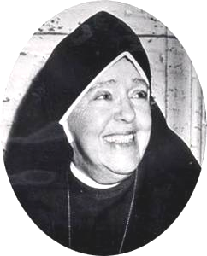

“I would have her distinguished by Christ-like charity and the saving grace of a sense of humor.” – MMJ

LETTERS
PLEASE, CONSIDER EMAILING US WITH ANY CONTRIBUTIONS. THEY WOULD BE SO WELCOME AND ENRICHING! IN ADVANCE, OUR GRATITUDE.

Kathleen Allgaier Gribble ’62 (Maria Faith) October 26th Appleton, Wisconsin
I feel so blessed to have this connection to my beloved Maryknoll Sisters. I was at Valley Park 1962-63. I may write a letter someday, but am too busy with several social justice groups in my community and the state of Wisconsin, as well as coordinating a Maryknoll Affiliate group and serving on the Affiliate Board. Next year - no more boards - more family visiting around the country and grandkid sitting. Thanks for keeping us connected! Kathleen (Kathie) G

Kay Wolfe Lent ’58 (Benedict Mary) October 28th El Paso, Texas
Feel free to print my words. I had opened the Newsletter to find the spelling for Ilia Delio so decided to go ahead and read the article. Wow, what exciting concepts! My mind doesn't grasp it all, of course, but what I get, I really like. One of my favorite phrases is: "I want everyone to see that we are loved into being at this moment just as we are by a God of unconditional love." (Did you read the positive things Pope Francis said about evolution?) While reading, I thought the article was written by someone in the Contemplative Community and wondered how they knew about the "Sopranos"?? Then at the end I saw it was written by Jamie Manson. I get both the National Catholic Reporter and America Magazine on line (and I've never paid for them but I sure like them and am grateful for them!) I've read a lot of Jamie's articles. Well then I went ahead and started Sister Elizabeth Johnson's article. Thanks again for such enriching reading! Luv kay

Mary Lou Andrews, MM ’49 November 1st
As ever, I enjoyed the last FC Newsletter. I read it carefully from cover to cover and I thank you for sharing it with me. I was especially impressed by Karen Peterlin’s account of her Retreat given by Sr. Terry Baldini. The material was beautiful, but what also helped to make the Retreat so special was Karen’s cutting out of all possible distractions before it began.
Thank you, Karen for your sharing.

Shirley Cocker Craighead ’54 (Miriam Elise) November 30th Moose, Wyoming
I’m always happy to receive the Newsletter. In the last issue, I was pleased to read the obituary on Betty Crooke. Betty was a member of my Group and I did visit her once in Bradenton. As well, we kept in touch by mail. Wasn’t she a beautiful lady?
If possible, I hope to be present at the 2015 Reunion. It will be a joy to see so many old friends. Sincerely in Christ’s Peace, Shirley

Mary Gracie Krieger, MM ’48 (Grace Marie) December 1st Maryknoll, New York
Thank you so much for the wonderful report on the celebration of my 90th birthday. (cf. Full Circle Newsletter, October 2014, p.9) The photo and article bring back wonderful memories of celebrating this special event in my life with people who are very special in my life – the Full Circle Coordinating Committee who represent the many beautiful women who have been an important part of my life and have contributed so much to my being who I am today.
I’m really impressed by all the things I am credited with doing for Full Circle. I may do some initial contacting but you can be sure your dedicated Committee members do all the work.
It is a blessing to work with the Committee, be part of the Reunion and connect with Full Circle Members in many other ways. Thank you for this blessing.
P.S. Please note the pineapple cake in the photo. The cake, made by Karen, was delicious!

Mary Lou Andrews (Rose Leon)’49 MM December 6th Maryknoll, New York
Love from Mary’s hill (knoll).
Blessings of this beautiful Advent Season leading to the Christmas celebration of Jesus, born of Mary by power of the Holy Spirit and given his Foster Father, Joseph.
Concerning me, on Jazzy Lee’s 13th Birthday, June 27, Jazzy Lee the 2nd came into my life. Reason for change of the power wheelchair is my Dropping Head Syndrome. To hold up my head is difficult. Jazzy Lee 2 leans back enough to make life much more comfortable for me.
My cancerous elephantiasis leg continues downhill, but very slowly, so hopefully it will last as long as I do. Bottom line, I am doing quite well.
This year because of my Dropping Head Syndrome, I was not able to go to Niagara Falls. Laurie, my sister-in-law came to see me. The long drive to and from Maryknoll left her with a blood clot and lung embolism, both very serious. Thanks to doctors and prayers, she is now well. We still enjoy visits by phone Saturday mornings.
Here at Maryknoll, life continues in an amazing wonderful way with daily Mass, Eucharistic Adoration, visits to our sick Sisters here, answering mission mail from our Fathers, Brothers and Sisters, also mail from 7 Prisoners around the US and all of you, my dear relatives and friends.
Pope Francis says concerning the necessity of joy in our lives: “The biggest dangers in life are Discouragement, Discord and the Doldrums. Don’t let them control you. Place your trust in God’s mercy and love.”
My love and prayers in Jesus, Mary and Joseph. Sister Mary Lou
PS No simple words can express thanks for all you do.

Letter written by Sr. Mary Lou Andrews on behalf of the Adoration Sisters
This has been a busy year with our General Assembly and the Society’s Chapter. Now we enter into the beautiful liturgy of Advent which leads us to Mary’s birthing of Jesus in Bethlehem.
We the Wednesday Adoration Sisters, have you, our Maryknoll family, as our focus of prayer. We are always grateful to receive details of your life and apostolate and your requests for prayers. Please send by PO snail mail. There is no time with God. Every request is received immediately.
Since writing to you last year, the following Adoration Sisters went to God and are praying for all of us in heaven: Sisters Antonetta Wilgenbusch, Mary Driscoll, Eleanor Keeney, Elizabeth Donahue and Agnes Christine Welscher.
Last year, I wrote about the history of our Wednesday Adoration program. About 25 years ago, a Sister told me of her encounter with Mother Teresa who was visiting her Sisters in Peru. Our Sister asked Mother to pray for Maryknoll. Mother Teresa said, “Maryknoll will do just fine because your Mother Mary Joseph started Perpetual Adoration. Prayer and works are so important; hence we continue to try our best. Have a blessed Christmas Season.
Our love and prayers in Jesus, Mary and Joseph, Sister Mary Lou for the Adoration Sisters.

Jeanne Rancourt MM (Marie Claude) ’56 December 16th Coelemu, Chile
My dear Family and Friends,
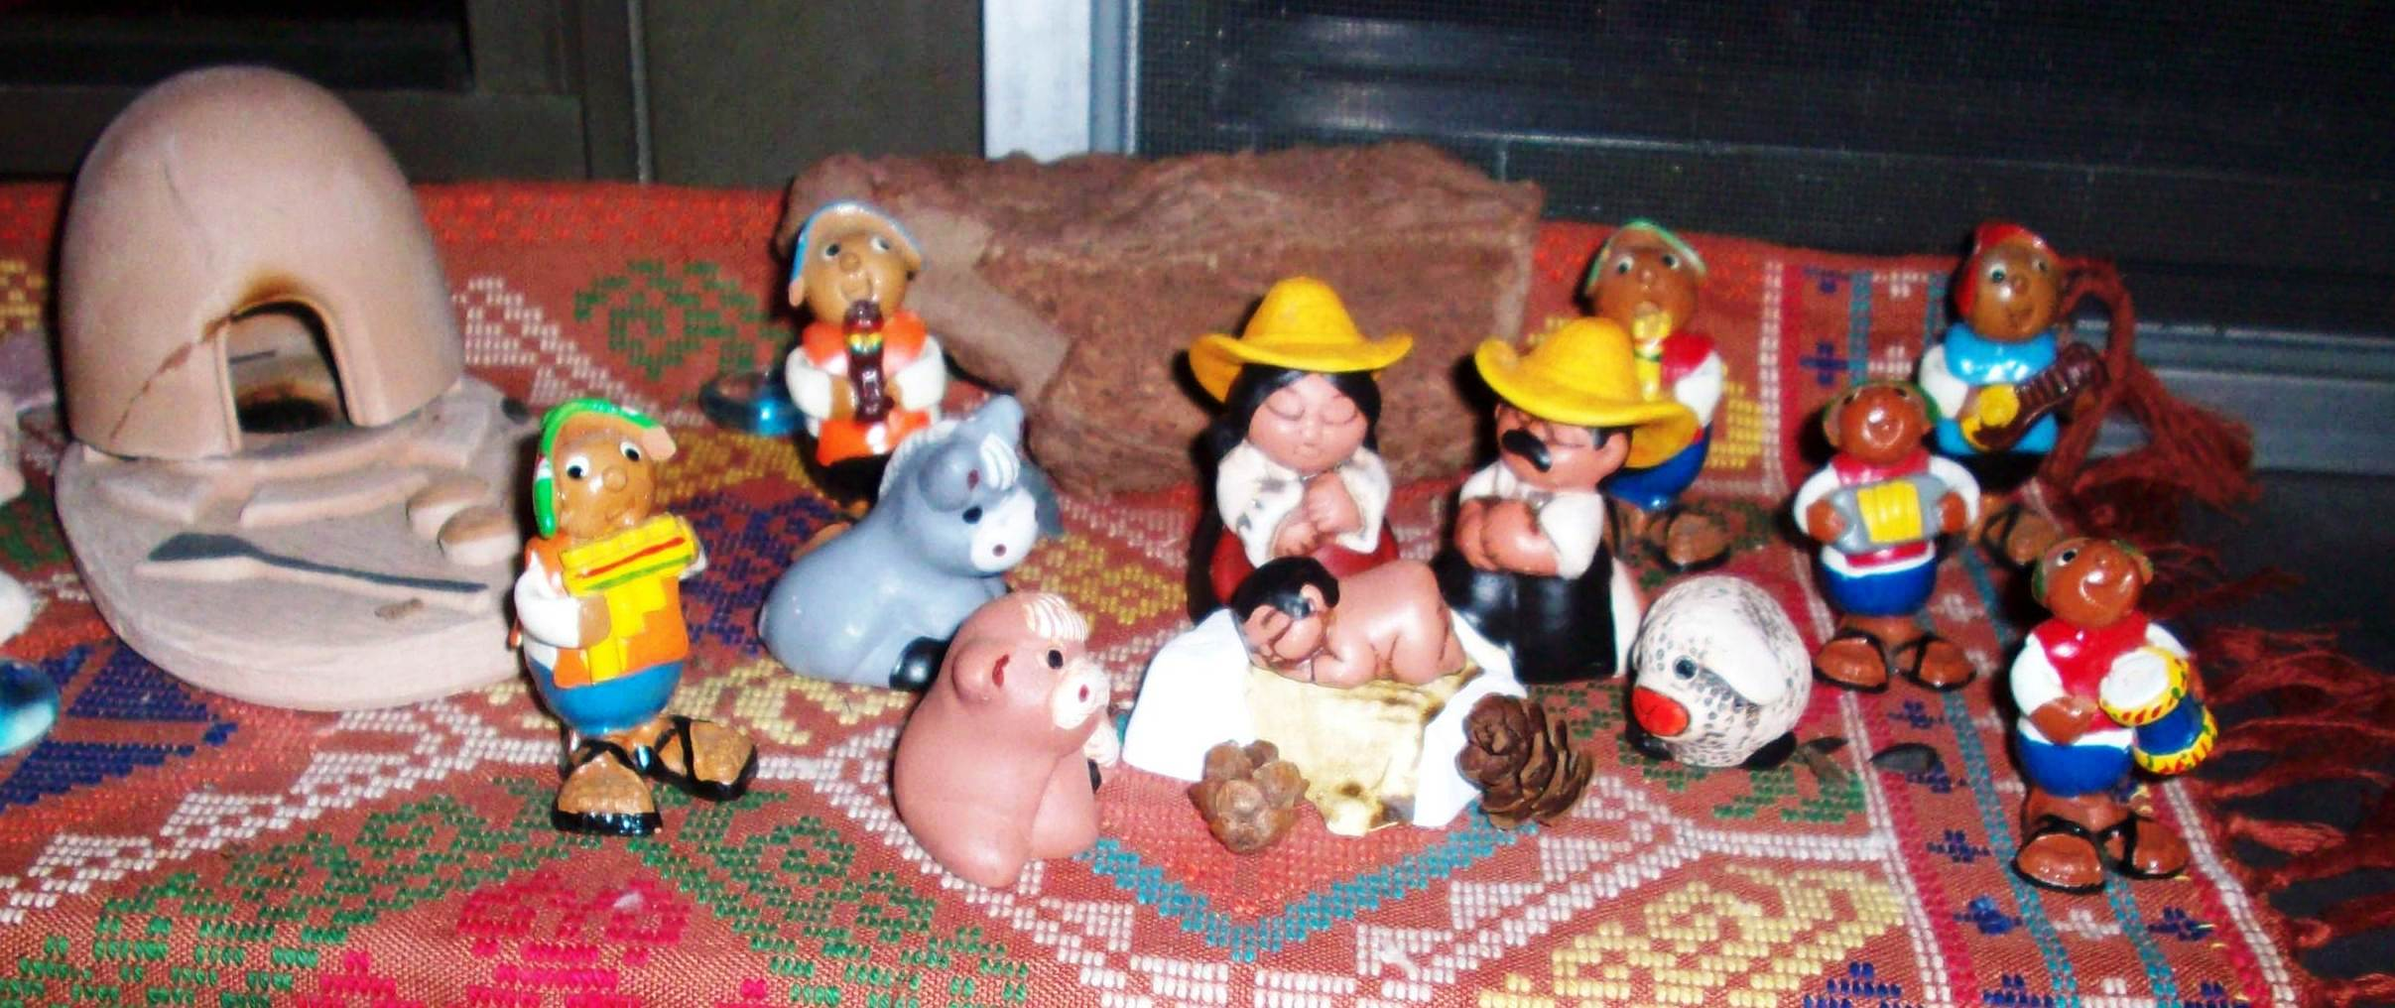
I come to wish you a very Blessed Christmas and a New Year filled with many unexpected blessings. Know that you are in my prayers and I do think of you all very often.
After 50 years, I will be leaving my beloved Chile. It is a very difficult move but it is the moment. I will be leaving in June and retuning to our Centerhouse in New York. As our Founder said: ”Let us go and see what God has in store for us.” I am opened to the Spirit and willing to serve the Lord in whatever capacity the Congregation will ask of me at this time. I ask for your prayers as I begin to say farewell to a people and culture that I have loved very much. The Sister I live with is also leaving Chile; she has been here 53 years. It is very difficult for both of us. We are only three Sisters in Chile and no other possibilities of receiving other Sisters. And as the Congregation is getting smaller, we must be willing to let go of some of our mission in order to be of service where there is more need.
I want to thank you, each one of you, for all the help you have given me throughout my 50 years of mission in Chile. The poor have benefited from your generosity. Also for all the support and interest you have shown. You have been very present with me in Mission. May you be rewarded a hundredfold. When I know where and what I will be doing after June 2015, I will write and let you know.
I continue to administer the home for the abandoned Elderly and my pastoral work in Family Catechetics. I will be looking for replacements for these two ministries. Do keep this intention in your good prayers.
My new direction after June 2015 will be:
Sister Jeanne Rancourt, Maryknoll Sisters Ctr 311, Maryknoll, NY, 10545- 0311 Phone: 914-941-7575

Pattie Caromongo ’60 (Wilfrid Marie) Christmas 2014 Forest Hill, California
Well, most know about the BIG move, but for those who don’t, we are now back in California! It was a major whirlwind event that started with the selling of our home the first day it was on the Market in June. We celebrated the grands birthdays with Aoife turning 5, Ben, 15, Caleb 17, Jacob, 25,Isabella, 4, Sophia, 9, Silas,13 and Seth, 21, in that order from Feb. to Nov., throughout the year. It’s unbelievable seeing the grandchildren growing so quickly.
Easter was at Tina’s. We spent the Saturday before at Dillon Beach on the Pacific. Maria joined us there and we had a lovely lunch at Tomales Bay. The Holbrooks joined us on Sunday and the egg hunt was on for Aoife, Sophia and Bella. More fun!
Our 45thAnniversary was spent, once again, at beloved Lake Tahoe, North Shore, thanks to friends of the Holbrooks who rented us their place at Rubicon Bay. Over the span of a week all our gang visited and spent time together and at the beach.
Moving preparations became serious in July. We brought our car and plants to the Holbrooks who housed us while we searched for a place of our own closer to the family. After we completed the tasks of sorting and packing, move out date was August 9th. Thank God for our Aglow friends who gave us boxes and packing materials! My precious two Kathy’s even helped pack our beautiful china.
We hired help to move us and son-in-law Brian drove the U-Haul to Auburn, CA, where the rest of the family waited at a storage facility. What a job that was with a team hard at work unloading! Their reward was dinner at Chevy’s restaurant where we all rejoiced that we were officially no longer in Reno!
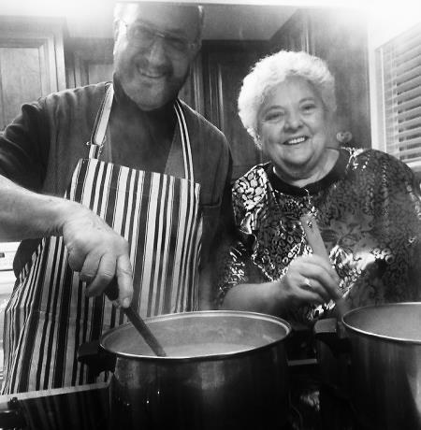
Looking for a house became our main focus the rest of Aug., Sept. and Oct. We even put a bid on a house close to Gina’s but backed out of it when the Home Inspection came in. Too much work to be done for two getting-older retirees!
Of course, during this time of disappointment the Lord was going before us and making us wait while all the pieces fell together for where we now are. Initially, we had seen this house in Sept. but felt it was way out of our price range. We decided to put an offer we could manage anyway. It was a miracle to us that the bid was accepted without a counter offer made. It was the RIGHT time! It’s absolutely perfect for us and all we can do is give thanks to our God for providing it. There’s even a workshop & shed! Thanksgiving was here and appropriately so!
We love our ”Narnia” in the forest and look forward to the rest of our years enjoying God’s mighty wonders here. We wish you all a very blessed Christmas praying that you, too, will experience your heart’s desires in the One who comes each Christmas. David and Pattie

Mary Annel ’57 (Maura Christopher) Blessed Christmas, 2014 El Salvador
My dear friends,
Merry and Blessed Christmas, 2014! May God’s love permeate all your being, and may you reach out to all those around you in love and peace! Know that you are always in my thoughts and prayers – at Christmas and all the year long!
2014 has been a busy year for us, as we in the CONTRASIDA (against AIDS) Foundation attempt to live our mission of preventing the HIV infection and gender-based violence, as well as accompanying people living with the virus. This year, we hired 3 people living with HIV who faithfully take their antiviral medicines, to search out and help others with the virus to do the same. The project has been a lot of work, but has resulted that people who take their medicines faithfully are good at convincing others to do so; it’s also resulted in their discovering and referring us people like Karina who needs the more intensive, personalized treatment we offer. We hope to help them back to health and direction of their own lives.
Despite a tightened economy, our Foundation is surviving with a more dedicated team, who keep training more pre-teen and adolescent, multiplier actor-teachers to help change a macho culture into respect for human dignity. For the next 5 years at least, we’re focusing on the young population who needs to examine their reality and change it into the future they desire.
I’ve morphed into everybody’s grandmother, loving and inspiring them to greater efforts against violence and HIV. I still see patients every Wednesday, which I love and which inspires me for the rest of the week to more efforts in fund-raising and national efforts to collaborate with others who work in AIDS. I’m not ready to retire yet, though I’ve slowed down a bit!
I also taught a month’s course in Public Health in El Salvador to pre-medical students from Jesuit colleges throughout the States, hoping to inspire them to working as doctors directly with the people and in community medicine. It was a lot of work, because I had to do it in English, and all my medical experience has been in Spanish, but I probably will continue annually.
A far as our Maryknoll Sisters’ community goes, we’re happy to report that besides Srs. Cecilia, Angela Brennan and I, we have a new, younger Sister Gloria Agnes from the Philippine Islands with us. We’re hoping to help her balance our community living with ministry. After a month’s getting her residency papers and orientation to El Salvador and our ministries, Gloria has decided to join our AIDS team, and will be working especially in her teaching profession with school reinforcement with children from families with HIV. We’re glad to have her with us.
Gloria and I came to El Salvador in October, after our Maryknoll Sisters’ every-five-years- General Assembly, with reports on where we’ll be going for the next years – and me, with a clean bill-of-health on my hip replacement. I keep falling, so need to pick up my right foot a bit more, and I navigate the broken sidewalks of El Salvador with a cane. I try to learn to be gracious about it all, but I still have some learning to do!
I continue to give thanks for you and for your loving support for me and my ministry here in El Salvador. God’s blessing be for each dear one and for all you love! Mary Annel

If you are going to try cross-country skiing,
start with a small country.

CARLA PIETTE NOMINATION TO APPLETON WEST HALL OF FAME
Jen Zettel, Post-Crescent Media PostCrescent.com jzettel@postcrescent.com; on Twitter @jenzettel
Four alumni will be inducted into the Appleton West Hall of Fame on Thursday, joining 47 others who have received the honor since the hall of fame's start in 1998.
Alumni are chosen based on academic and professional achievements, awards, recognitions and civic achievements. An induction ceremony will take place during homecoming festivities. This year's inductees include: Arnie D. Fielkow, class of 1974.and Bob Landis, class of 1958 Ethel Courtois Keller, class of 1939 as well as:
Carol Ann Piette, Sister Carla class of 1957. As a member of the Maryknoll Sisters, Sister Carla dedicated her life to serving the poor and marginalized, first in Chile from 1964 to 1979. She taught children and later lived among impoverished families.
She moved to El Salvador in 1980, risking her life to deliver food and emergency supplies to poor women and children caught in the midst of civil war. She died on Aug. 23, 1980, when a flash flood swept her away while she was transporting a released prisoner. The Salvadorans named her "Angel of Charity." Each year local villagers gather in her memory at the river where she died.

RESPONSES TO CARLA’S TRIBUTE
Kathleen Allgaier Gribble ’62 (Maria Faith) October 31st Appleton, Wisconsin
A week ago I attended another tribute to Carla at her parish here in Appleton. A group of her classmates created a memorial plaque with photo of Carla and presented it to the pastor of St Mary Parish. A presentation was done by her friend and classmate, Jackie Maggiore, Maryknoll Affiliate coordinator of the Milwaukee chapter. Jackie has written a book, Vessel of Clay, about Carla's life. I will be representing Maryknoll in a few weeks, Nov 17-19th, at a mission - Hearts Wide Open - by Jack Jezreel of Just Faith, for the Catholic parishes in the area. I will be also be promoting this book about Carla. I get involved in a lot of community efforts here and coordinate a small MKNL Affiliate chapter, Fox Cities, Wisconsin Chapter. Four of us are heavily involved with an interfaith social justice organization, ESTHER, (estherfoxvalley.org). Lots going on here and great collaboration efforts.
You and any other Full Circle members are always welcome to my home in Appleton when they come to Wisconsin. It's a great community to visit and not too far from Door County.

Joan McAuliffe ’58 (Timothy) November 1st Stevens Point, Wisconsin
Thank you for sending this. To me, she will always be Sister Rose Carol, of the enormous smile. Didn’t realize she had Wisconsin roots. Joan

The very least you can do in your life is to figure out what to hope for.
And the most you can do is live inside that hope.
Barbara Kingsolver

BAZAAR 2014
This year, the Bazaar was again held in the auditorium. What a gathering! Most booths sold out completely and the intake was the largest ever. As always, the monies received through the sale of raffle tickets was the largest part of the revenue. A difference, this year, was opening up the Full Circle database to the Sisters in order to send out raffle tickets. The raffle brought in approximately $150,000. Unfortunately, we are unable to report an exact total of Full Circle’s contribution to the raffle sales, but it was significant. Your response was very generous & much appreciated. Way to go!!!
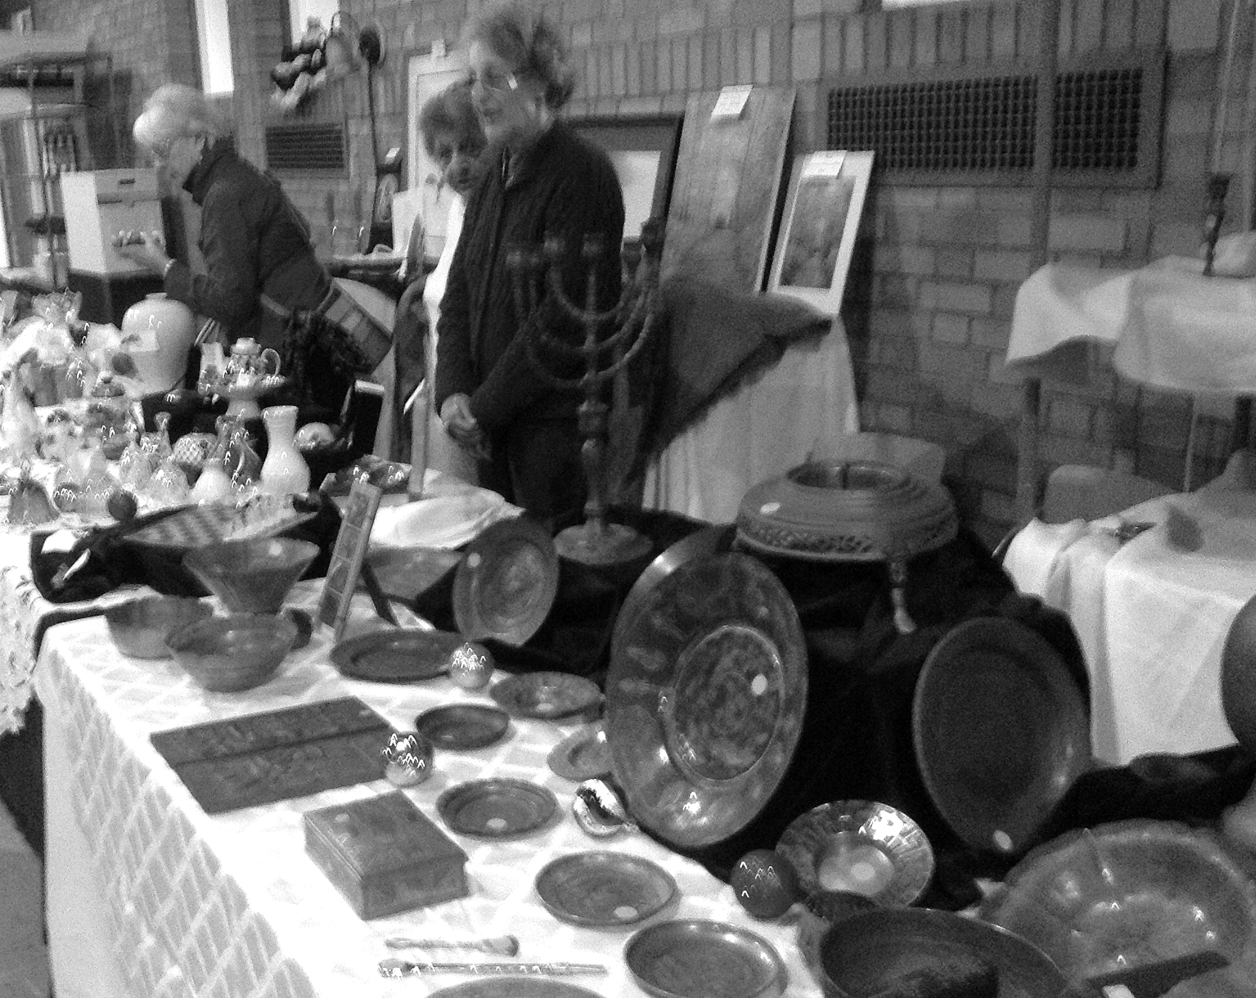
As usual, so many Full Circle members, Affiliates and friends came and worked the bazaar. A partial list would be Betty Hayes come from South Carolina. She came the week prior to help wrap up cart-loads of Maryknoll Breakfast Bread, cookies, breads and other tempting goodies made in the bakery, recently rededicated to Sister Anne Cecelia. Janet Arndorfer came from Portland, Oregon a week ahead to help in the Golden Fleece Booth with the unwrapping of gifts from various donors – mostly treasures from someone’s home. These had to be looked up on the internet for value, silver polished, china washed, linens washed and pressed and then set up on tables. Fran Rossi came by train from Chicago a week ahead to help set up and later to help sell and greet folks as they came in the front door. This was a new feature of the Bazaar. Ginny McEvoy took this on and created a warm and welcoming mood. Ginny went shopping on her own before the Bazaar and bought bags of tootsie lollypops that she gave out to the children as they came in. It was not only the children who partook! Besides managing her own station, Ginny came on Wednesday and with Janet Arndorfer set up the tables. Ginny’s artistic eye was evident, and several commented that our table was the best ever. Consu Torrecer MM added much class to the table by making signs with her wonderful calligraphy with names of items and prices. This really added to the elegance of the table. Anka Kondraska came the night before to put on the finishing touches and then spent the Bazaar day managing the wrapping table, making certain that all the purchased crystal, Hummel’s, china, was securely wrapped. Not an easy task! She then stayed until Sunday in order to take down the booth and put away the few items that were not sold. Sheila McKenna came and worked, bringing with her boxes of items that were hand woven, knit, and crocheted by her. Roselani Smith and Rose Tocci came midweek to help in China/Taiwan, again, setting up, and then selling on the day. Debbie Kair worked from dawn to night selling, packing, managing traffic. Ro and Jerry Hardiman came in from Delaware to help sell raffle tickets, Myra Greene from Rhode Island to help with the pricing in the Golden Fleece Booth (Myra works in a resale shop and therefore was of tremendous help with marking items). Maryknoll Affiliates helped as well: Agnes Walsh, Ronnie Gilligan and Jim McCullough (who works for the Fathers) and his wife, Jerry, came to help set up the Golden Fleece and then managed a team to welcome the shoppers on the day of the bazaar and truly doing crowd control.

Janet Arndorfer ’58 (Bernard Corde) December 19th Portland, Oregon
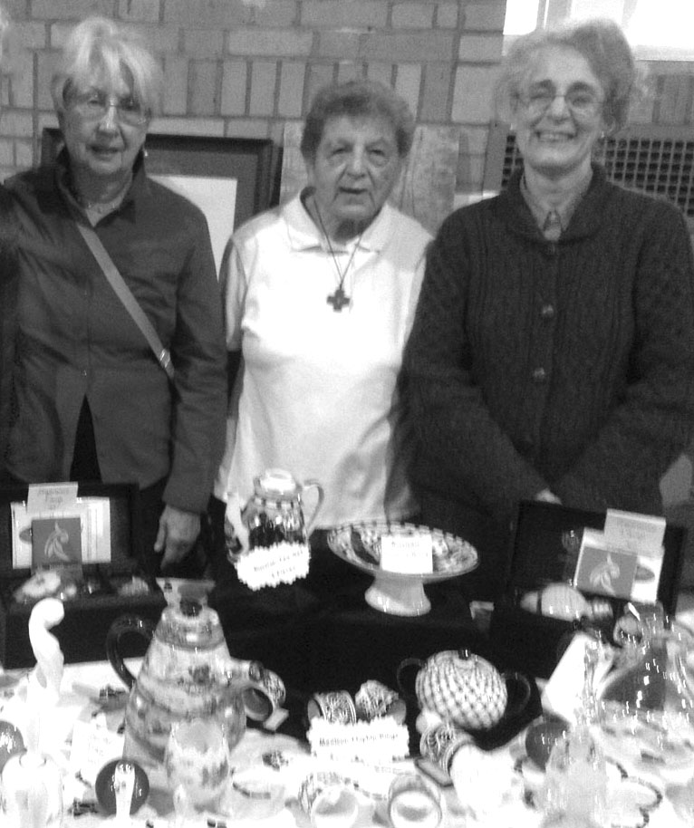
The annual Holiday Bazaar was held in October and took over the basement floor, main building, (refectory/dining room floor) of the Motherhouse. There were booths selling items from mission countries, a booth selling donated items that were not high end, and a booth selling donated items that were high end. There was also a room with art objects that were created from the original molds of Sister Marie Pierre and in the halls; wonderful Maryknoll baked goods and other yummy foods.
Karen Peterlin was responsible for the Golden Fleece (three tables of the high-end donated items.) Thursday morning, before the Saturday Bazaar, we unpacked boxes of china, crystal, silver, antique dolls, old and rare books, linens, paintings and lithographs, chess sets and antique brass including all manner of pots, candelabra, platters and pitchers. Everything was sorted, priced and a great deal of intense effort went into an artful display.
Janet Arndorfer, Fran Rossi, Gerry McCullough
In the late afternoon on Thursday, after all the displays and cleanup of old boxes and wrappings were finished, I walked through the gym (where most of the booths had been set up) and was quite impressed with the vividness and quality of all the tables selling items including the mission tables and the Golden Fleece. It was going to be a unique and beautiful sale.
Here are some interesting transactions at the Golden Fleece table: Saturday morning, as I reported to my place behind the Golden Fleece table, I noticed a little girl about five and her father in front of the antique dolls. As I got in front of them, I could see she was looking at the antique (and previously well-loved bridal doll. It was on a stand and I moved it to the edge of the table and asked if she wanted to see that doll. Well, she picked it up, stand and all, put it under her left arm and turned to walk off. Her dad grabbed her, paid for the doll and they left smiling at each other. Two of our first happy customers.
We had two folios of richly painted Madonnas, Christ Childs and saints. One set showed sacred pictures depicted as North and South American Indians. Another folio displayed sacred pictures as Crow Indian. A gentleman said he had been a social worker in Canada working with the Crow Indian Community. He was very drawn to that folio and came later to buy it.
We had five or six rare books. On the day before the Bazaar, Karen and I had a quiet coffee break in the dining room while we reached and priced the books on her I Pad. One, of particular interest, was a small five by five inch book dating from the 1850’s. It was in a rather raggedy shape entitled “Chloe, the Little Slave Girl.” It was the story of Chloe, and beautifully illustrated in pen and ink. It went, not to a rare book collector, but to a young woman in love with its unique story.
We had a small Hummel of a shepherd boy that had a tiny chip. It had been displayed for the past two bazaars, without being sold. This year, Karen took it to Sister Peg Dawson who flawlessly repaired it. It sold readily. We had a lovely set of napkins and tablecloth, all with beautifully hand stitched blue violets. The napkins were stained and Karen took them to the laundry. They were returned sparkling clean and they sold.
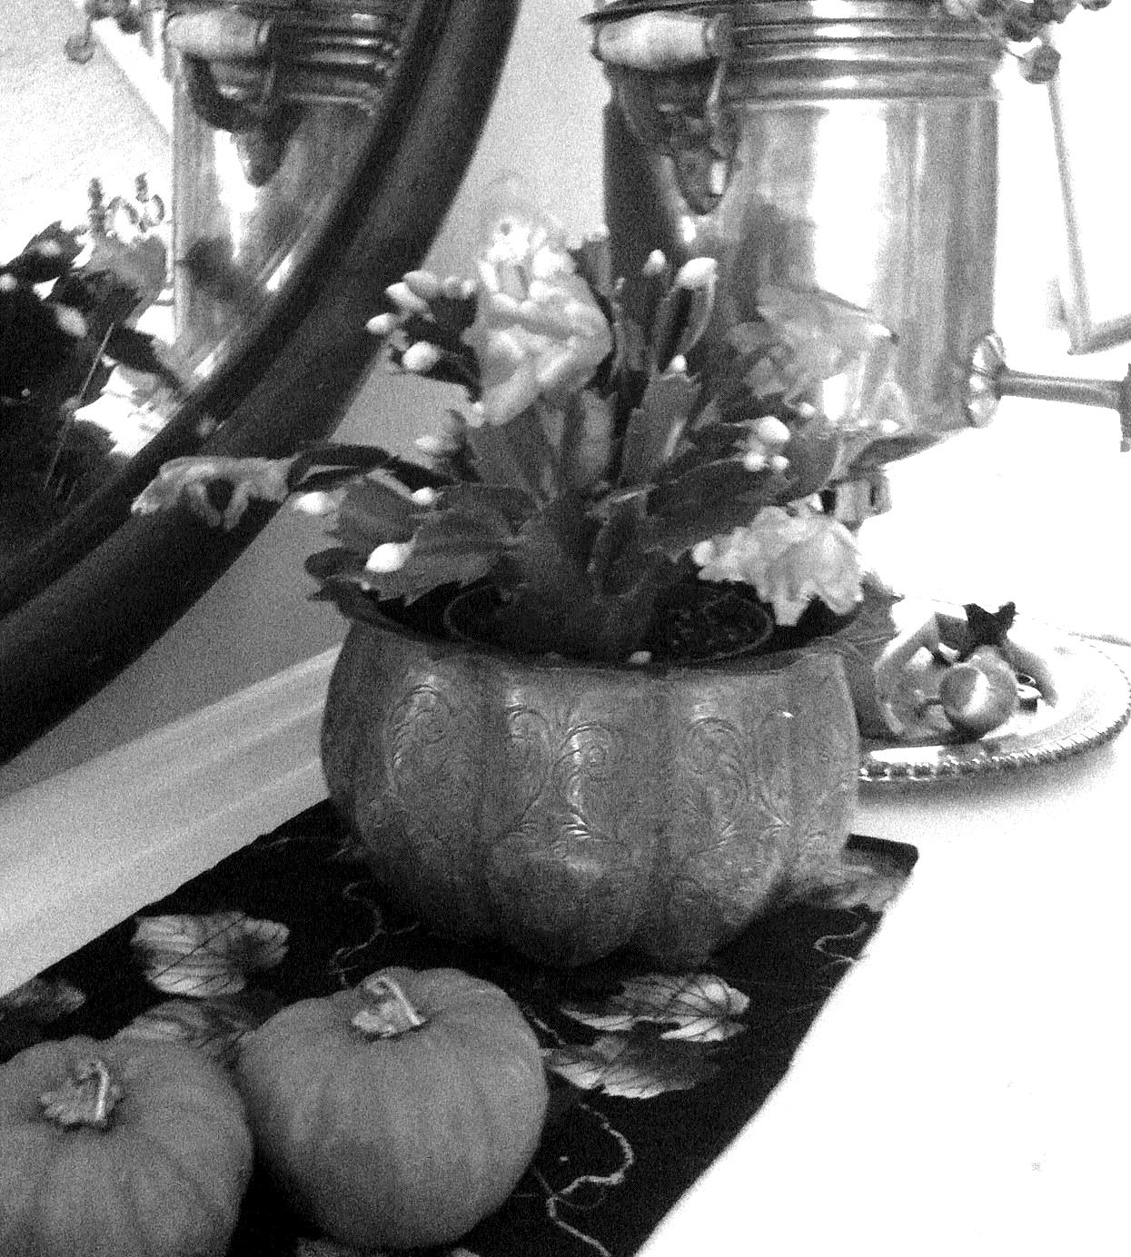
The brass items were of great interest to many people and Sheila McKenna, who had collected the items during her travels after she left Maryknoll, came over to our booth a couple of times to talk with prospective buyers. Most of those items sold, and a small charming one came back to Portland, Oregon with me and sits with a Christmas cactus in it. Those of us working felt it was a productive and interesting opportunity to give back to the Maryknoll community.

God has yet a great work for us to do. Mother Mary Joseph

NEW CONGREGATIONAL LEADERSIP TEAM (CLT)
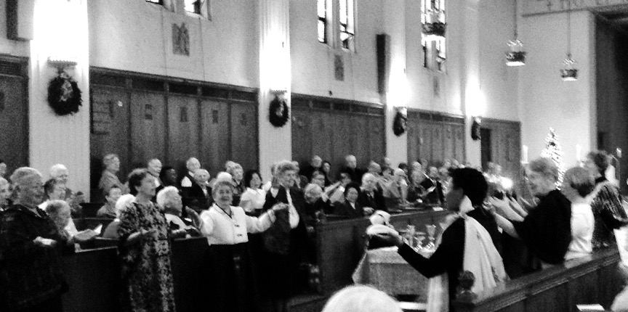
Installation of the new Congregational Leadership Team of the Maryknoll Sisters (CLT) took place during Sunday Liturgy on January 4, 2015 at the Motherhouse. Leadership members of the Maryknoll Fathers & Brothers, Maryknoll Lay Missioners, Maryknoll Affiliates and Full Circle were present.
(Information on the new CLT: http://www.maryknollsisters.org/articles/following-gods-lead)
REUNION 2015
Women in Church Leadership in the 21st Century
This year, we are planning a panel to discuss the unfolding role of women in the Church. Presenters will be Betty Donnelly, Barbara Duff ’61, Madeline Labriola and Noreen Mooney ‘60. The panel will be moderated by Ginny McEvoy ‘61.
For more information please go to our website. http://www.fullcirclemks.org.
Some Reflections of Mother Mary Joseph as Whole Maker.
On Sunday, April 26, we have also arranged a day of retreat. Retreat Leader is Theresa Baldini, MM ’55 (Anne Paul). Additional information is available on our website.

To learn how to live graciously together would make us worthy
of this unique beautiful blue planet
that was prepared for us over some billions of years
a planet that we should give over to our children with the assurance
that this great community of the living
will nourish them, guide them, heal them and rejoice in them
as it has nourished, guided, healed, and rejoiced in ourselves.
Thomas Berry

PRAYER CORNER
Freedom is not knowing, Richard Rohr OFM from Things Hidden: Scripture As Spirituality, pp. 37-39
It seems that God is asking humanity to live inside of a cosmic humility, as God also does. In that holding pattern, we bear the ambiguity, the inconsistencies, and the brokenness of all things (which might be called love), instead of insisting on dividing reality into the supposed good guys and the certain bad guys as our dualistic mind loves to imagine. Such non-dual consciousness is our ultimate act of solidarity with humanity and even the doorway to wisdom. With this mind we realize, as Martin Luther wisely put it, we are simul justus et peccator, simultaneously both sinner and saint. Only the mind of God can hold these two together.
We read the story of humanity’s original sin in Genesis. There Yahweh says, “Don’t eat of the tree of the knowledge of good and evil” (Gen. 2:17). Now why would that be a sin? It sounds like a good thing, doesn’t it? We were actually trained to think that way.
In the seminary we took serious courses on “moral theology” to help us rightly discern who was good and who was bad. Unfortunately, this usually only emboldened the very judgmental mind that Jesus warned us against (see Matthew 7:1-2). Some then thought that this was the whole meaning of Christianity—religion’s purpose was to monitor and police society in regard to its morals. Religion became all about morality instead of being a result and corollary of Divine Encounter. As such, this was much more a search for control or righteousness than it was a search for truth, love, or God. It had to do with the ego’s need for certitude, superiority, and order. Is that what Jesus came for? Jesus never said, “You must be right,” or much less, “You must be sure you are good and right.” Instead he said, “You must love one another.” His agenda is about growing in faith, hope, and love while always knowing that “God alone is good.”
I guess God knew that dualistic thinking would be the direction religion would take. So the Bible says right at the beginning, “Don’t do it!” The word of God is trying to keep us from religion's constant temptation and failure—a demand for certitude, an undue need for perfect explanation, resolution, and answers, which is the exact opposite of faith. Such dualistic thinking (preferring a false either/or to an always complex reality) tends to create arrogant & smug people instead of humble and loving people. Too much “eating of the tree of the knowledge of good and evil” might just be the major sin of all religion—especially Judaism, Christianity, and Islam. The Bible’s first warning has consistently been ignored.

Nan C. Merrill Praying the Psalms (Based on Psalm 119)
When you dwell in peace within God’s heart, you take on God’s way of Loving. You radiate the healing love of your inmost being into a suffering, scarred, yet ever-sacred world, offering grateful praise from the chalice of your heart to God, who loves in and through you. Great peace has those who love beyond measure, for it is there miracles happen.

Blessing Prayer (Source Unknown).
May we have food in the bowl to feed what is basic, and nourishment in the heart to feed hungers move wild. May the God of the Feast draw us to a welcome table where we know communion and delight and rest!

BON MOT CORNER
We all get heavier as we get older because there's a lot more information in our heads. That's my story and I'm sticking to it.

I intend to live forever. So far, so good.

MARYKNOLL CONTEMPLATIVE COMMUNITY AT THE CHALET
New Year's Blessings from the Chalet! Sr. Terry Baldini
#14 Living into a New Consciousness
Summary of Reflections by Ilia Delio, OSF,
at the Maryknoll Sisters General Assembly
We live in an age of unparalleled transition within religion, a major cycle which occurs every 2000 years. The artificial separation between humans and cosmos is at the root of contemporary moral confusion (Teilhard). On the other hand, Catholicity is the consciousness of the whole. Cosmology is the order of the whole. The very name of God (I AM) is a cosmological notion. In the mechanistic worldview of heliocentrism (the sun as the center) and the rise of modern science, religious life was structured mechanistically, with focus on the rule. A religion built on stability and immutability is ill prepared for a cosmic shift.
Einstein’s theory of special relativity teaches us that there is no such thing as time alone; it is not a universal constant. One consequence is that the past, the present, and the future are not absolutes. So we learn to enter an understanding of deep time. Deep time is geological time, and reflects the idea that in the time range of the history of the great cosmological and geological events, human history represents a tiny fraction.
Evolutionary Consciousness refers to the emerging awareness that we human beings are affecting the current and future course of evolution itself.
Evidence of this is experienced in climate change, in the near collapse of life support systems, and in the entire range of global crises, most of which are ultimately related to control over diminishing Earth resources.
Interpreting Evolutionary Consciousness within our faith tradition, we are urged to exercise our inherent co-creative capacity by making clear choices and decisions for the future that are aligned with the evolutionary trajectory toward the fullness of life in Christ.
Evolutionary Consciousness invites us Maryknoll Sisters, of all cultures, ages, ministries, and understandings, to join with others in bringing forth a profound sense of shared responsibility for the future of the living Earth, the well-being of the community of life, and the good of all people.
We ask: What is our role in bringing forth a positive future for all?
The participating universe is full of possibilities and potentialities that affect each other. We are energy packed matter. There is no line between subject and object. Heisenberg’s uncertainty principle says every time I measure something, I alter its properties. Naming something as real makes it happen.
Quantum entanglement describes the sustained relationship between two quantum particles even at great distance from each other. It becomes another expression of the mystery of relationship at the heart of the universe.
When we are bound together, our actions affect each other.
What we think and do affects others.
Evolution is not background to the human story. Evolution is the human story.
What we are today is not what we will be tomorrow. Evolution is the rise of consciousness and new forms of life. There are two main influences on evolution: culture and climate change.
We are part of an indivisible whole. Our actions and thoughts are not ours alone. When we pick a flower, we move the farthest star. When we cannot get over our hurt and anger, we contribute to the pain of the world. Because we fail to forgive, we are responsible for war and violence in creation.
As we become consciously part of a whole part, we enter into this mystery, one that is indeterminant, uncertain, full of ambiguity, and one, which calls us to trust. We are either part of the cycle of violence or part of the cycle of love. If we do not let go of the tempest within, we are perpetrating that field in the world. Each of us moves things along in the direction of war every time we fail in love. We are radically connected in the world, and radically responsible for it.
Conscious Evolution requires inner freedom in which the mind/body is in tune with God, self, and environment ~ attuned to a new future. There is the inner freedom to let go and engage new structures and relationships, and there is an awareness of incompleteness and participation in creating the world ahead. This inner freedom deepens our humanity.
Theology is intertwined with cosmology. As the cosmos changes, our understanding of God changes. God is love and love is relational (Trinity).
Jesus is the Whole Maker who restores to health, shows compassion, reconciles.
Salvation is to heal and make whole.
The death of Jesus leads to the coming of the Spirit and the new creation. Death is not the end, but a fullness of life. The death of Jesus forms a new matrix of divine-created energy in the cosmos. The resurrection of Jesus the Christ speaks of a new future for the whole cosmos, “the invasion of the present by the power of what is yet to come.”
Thus, Christianity is a religion of evolution. Heaven is not a place of disembodied spirits, but an embrace of love that transforms this present earthly life with its frailties and weaknesses into the divine presence of enduring love. The communion of saints is the quantum entanglement from earth to heaven. Heaven begins in the now — the whole of reality is Christic as all the fragments are gathered and nothing is left out.
Conscious Christogenesis is this new being on the horizon of the already existing now; Christ Omega is within and yet before us, realized and unrealized, whole and incomplete. The very being of the world is being personalized; not something but someone is in evolution.
All of us have different levels of understanding of new consciousness, and we must be patient with ourselves but keep our vision in mind. New consciousness works best locally rather than globally. Those who “fire together, wire together;” that is, they share a field of energy. We can open spaces where ideas can be articulated, and we can see which speak more collectively and which do not. We accept that an open system has chaos built into it.
We can integrate our values of mission with the new theology by being a stable community sent out to be with others as wholemakers. This same dynamic should play out in our own lives as sisters and members of a congregation. We carry the same spirit of openness and letting go from our mission community into the congregation.
We trust in divine love with openness to possible death in our congregations, which face smaller numbers, aging members, and financial concerns. We need to know what is worth dying for because then it is worth living for.
The energy produced from our interactions and values inform morphogenetic fields. When we share the same values, we strengthen the fields; weak fields exist where there are conflicting values. These work best locally where simplicity of core values can animate us and give us the freedom for our lives to develop.
If we want a different world, we must become a different people.
Evolution does not stop with Jesus, but is an ongoing process. Jesus himself, in scripture, noted that those who follow him will do even greater works than he did. Christogenesis is the cosmic person who is coming to be.
Evolution does not end with us. Life is always moving forward toward greater unity and complexity. Conscious evolution recognizes that connectedness is a basic reality of our existence and that all we do affects the whole. Since we are impacting the world around us, we need to center our minds on love.
All world religions share this universal ideal of love. With this conscious catholicity we embrace that evolution is the rise of consciousness, of love, of God.
We are called to make whole, be whole, and have mindfulness of the whole.
We need to allow ourselves to dream of what religious life in the church would look like. This is integral to evolution. We could live a poverty of being able to let go and let love flow, with a presence and focus to our love and openness to the flow. We could live without possessing, and offer suffering from our individual lives for the goodness of the whole.
Absolute love does not save us from suffering,
but empowers us to create life amid suffering.
Lessons from evolution are that we are unfinished, that death is part of life, and that we are dynamic beings who accept our incompleteness and are open to the future. We need to create a structure to fit the needs of the moment, and as the moment changes, so too does the structure. Planning for the future should not anticipate precise outcomes but rather link up people, projects, goals, and dreams, taking into account that there are people around the globe in different stages.

The Seven Principles of Evolutionary Consciousness:
Future oriented;
Visionary;
Considers the largest context possible;
Uses whole-systems thinking;
Looks for opportunities, not problems;
Believes that together we can do all things;
Each one accepts her unique responsibility.

For more amazing contributions from the Maryknoll Contemplative Community, please see the Full Circle Website: http://www.fullcirclemks.org

Be Alert. The world needs more lerts.

PHILOSOPHY CORNER
7 Things Remarkably Happy People Do Often Inc.com by Jeff Hadel/Inc.
Happiness: everyone wants it, yet relatively few seem to get enough of it. Good news and bad news: unfortunately, approximately 50 percent of your happiness, your "happiness set-point," is determined by personality traits that are largely hereditary. Half of how happy you feel is basically outside your control. Bummer.
But, that means 50 percent of your level of happiness is totally within your control: relationships, health, career, etc. So even if you're genetically disposed to be somewhat gloomy, you can still do things to make yourself a lot happier. Like this:
1. Make good friends.
It's easy to focus on building a professional network of partners, customers, employees, connections, etc., because there is (hopefully) a payoff. But there's a definite payoff to making real (not just professional or social media) friends. Increasing your number of friends correlates to higher subjective well-being; doubling your number of friends is like increasing your income by 50 percent in terms of how happy you feel.
And if that's not enough, people who don't have strong social relationships are 50% less likely to survive at any given time than those who do. Make friends outside of work. Make friends at work. Make friends everywhere. Make real friends. You'll live a longer, happier life.
2. Actively express thankfulness.
According to one study, couples that expressed gratitude in their interactions with each other resulted in increases in relationship connection & satisfaction the next day--both for the person expressing thankfulness and for the person receiving it. (In fact, the authors of the study said gratitude was like a "booster shot" for relationships.) Of course the same is true at work. Express gratitude for employee's hard work and you both feel better about yourselves.
Another easy method is to write down a few things you are grateful for every night. One study showed people who wrote down 5 things they were thankful for once a week were 25% happier after ten weeks; in effect they dramatically increased their happiness set-point. Happy people focus on what they have, not on what they don't have. It's motivating to want more in your career, relationships, bank account, etc. but thinking about what you already have, and expressing gratitude for it, will make you a lot happier. And will remind you that even if you still have huge dreams you have already accomplished a lot--and should feel genuinely proud.
3. Actively pursue your goals.
Goals you don't pursue aren't goals, they're dreams & dreams only make you happy when you're dreaming. Pursuing goals, though, does make you happy. According to David Niven, author of100 Simple Secrets of the Best Half of Life, "People who could identify a goal they were pursuing were 19% more likely to feel satisfied with their lives & 26% more likely to feel positive about themselves. "So be grateful for what you have, and then actively try to achieve more. If you're pursuing a goal, make sure that every time you take a small step closer to achieving it you pat yourself on the back. But don't compare where you are now to where you someday hope to be. Compare where you are now to where you were a few days ago. Then you'll get dozens of bite-sized chunks of fulfillment and a never-ending supply of things to be thankful for.
4. Do what you excel at as often as you can.
You know the old cliché regarding the starving yet happy artist? Turns out its true: artists are considerably more satisfied with their work than non-artists--even though the pay tends to be considerably lower than in other skilled fields.
Why? Clearly the more you enjoy what you do and the more fulfilled you feel by what you do the happier you will be. When volunteers picked one of their signature strengths and used it in a new way each day for a week, they became significantly happier and less depressed. Of course it's unreasonable to think you can chuck it all and simply do what you love. But you can find ways to do more of what you excel at. Delegate. Outsource. Start to shift the products and services you provide into areas that allow you to bring more of your strengths to bear. If you're a great trainer, find ways to train more people. If you're a great salesperson, find ways to streamline your admin tasks and get in front of more customers. Everyone has at least a few things they do incredibly well. Find ways to do those things more often. You'll be a lot happier. And probably a lot more successful.
5. Give.
While giving is usually considered to be unselfish, giving can also be more beneficial for the giver than the receiver. Providing social support may be more beneficial than receiving it. Intuitively I think we all knew that because it feels awesome to help someone who needs it. Not only is helping those in need fulfilling, it's also a reminder of how comparatively fortunate we are--which is a nice reminder of how thankful we should be for what we already have. Plus, receiving is something you cannot control. If you need help--or simply want help--you can't make others help you. But you can always control whether you offer help. And that means you can always control, at least to a degree, how happy you are--because giving makes you happier.
6. Don't single-mindedly chase "stuff."
Money is important. Money does a lot of things. (One of the most important is to create choices.) But after a certain point, money doesn't make people happier. After about $75,000 a year, money doesn't buy more or less happiness. Beyond $75,000, higher income is neither the road to experience happiness nor the road to relief of unhappiness. "Perhaps $75,000 is the threshold beyond which further increases in income no longer improve the ability to do what matters most to emotional well-being, such as spending time with people they like, avoiding pain & disease & enjoying leisure. "And if you don't buy that, here's another take: The materialistic drive & satisfaction with life are negatively related. Chasing possessions tends to make you less happy. Things only provide momentary bursts of happiness. To be happier, don't chase as many things. Chase a few experiences instead.

7. Live the life you want to live.
Bonnie Ware worked in palliative care, spending time with patients who had only a few months to live. Their most common regret was, "I wish I'd had the courage to live a life true to myself, not the life others expected of me. "What other people think--especially people you don't even know--doesn't matter. What other people want you to do doesn't matter. Your hopes, your dreams, your goals... live your life your way. Surround yourself with people who support and care not for the "you" they want you to be but for the real you.
Make choices that are right for you. Say things you really want to say to the people who most need to hear them. Express your feelings. Stop and smell a few roses. Make friends, and stay in touch with them. And most of all, realize that happiness is a choice. 50% of how happy you are lies within your control, so start doing more things that will make you happier.

Our actions become the ground we walk on.

POETRY CORNER
Carolyn Cook Grassi ’60 (Teresita Marie) Pacifica, California
From her book Heart and Soul Patmos Press, San Francisco, California 2014.

Ipswich Bird Sanctuary Massachusetts
Clouds were drifting across a wide blue sky over
the wild wheat fields of the Bird Sanctuary. Sap
dripped down pine trees. Pussy willows were waving
by the stream during those years when I was in my
early twenties, preparing for Profession Day during
our Novitiate training. Allowed an afternoon off
once a week for hiking, reading, day-dreaming.
A group of us relaxed on a ledge overlooking
the Rockery’s silvery pond. Sharing hopes for
future missions to the Serengeti plain, the Andean
Altiplano, Bolivian rainforests, Pacific Islands, Manila,
Hong Kong, Kyoto, Cochabamba serving the poor
As a social worker, teacher, community organizer,
catechist, nurse, doctor. Linda longed to visit
her family in Saugerties. No one mentioned missing
the world, code for life outside the convent. We
never mentioned men, past or present. Mary Jane
spoke nostalgically of her college years. Everyone
laughed at Beth’s stories of working at Seagram’s
in New York City. Helen sketched the ruins,
an abandoned estate we hiked through on our way
to the Bird Sanctuary. She drew a couple on
the terrace overlooking the apple orchard. Did
she have a romantic past? Did any of us? We
chased each other through the fields, tumbling
onto a soft blanket of wheat, the way kids fall
with their arms open wide as angels in the snow.
Red-tail hawks few by, bees buzzed round
my fingers, finches darting by my face, earth’s
warmth beneath my body. Our spell broken by
Connie calling: “Hurray! We’ll be late for chapel!””
Rushing to the gate, I turned for a last look
before running after my sisters, veil flying,
dogs chasing, scapular catching on brambles.
Breathless in chapel, Linda smiled across the aisle,
as we lay prostrate on the granite floor doing
the Venia penance for our being late for Vespers.

What we do for ourselves dies with us.
What we do for others and the world remains and is immortal.
Albert Pine

BLOGS and DIARIES
Terry Herman Sissons ’58 (Bernadette Mary) Dec 8th Royston Herts, England
http://theotheri.wordpress
Here in England, for obvious historical reasons, Thanksgiving is not a national holiday. But surprisingly, 1 out of 6 families do celebrate Thanksgiving. We are one of the 1/6th.
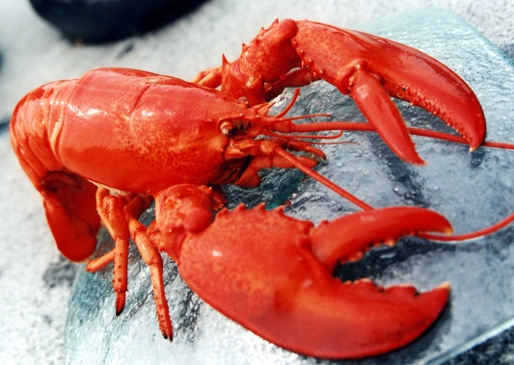
This year we had no visiting relatives or friends, and we decided to forego the traditional turkey. Canadian waters have produced a surfeit of lobsters that are now flooding our supermarkets, and we thought instead of the turkey, we’d indulge in lobster. We prepared a festive dinner, and after a few pre-dinner drinks, finished preparing the dinner by putting the lobsters into boiling water for the prescribed number of minutes. The table was set, but we decided to crack open the lobsters and remove any inedible bits before taking them to the dining room.
Unfortunately, when we opened them, the lobsters contained very little meat. I learned today from a friend that in America, lobsters weighing less than a pound and one half are called “chicken lobsters.” They look like adults but are not yet mature and have little meat.
Well, they might be called chicken lobsters in the States. But ours were real turkeys.
We still celebrated Thanksgiving. I reached into the freezer and took out a couple of pizzas we’d made earlier in the month. The champagne helped the thanksgivings along.

Mary Gill ’56 (James Anthony) May 14th Oaxaca, Mexico
Hello all, well we feel time flying, and here we are almost in September. I find myself with plenty to do, respond to and pray about! The good news is we have our permission to build the two therapy rooms and they should be done in about a month…the permission is until Nov. 22 but Victor, our architect/contractor says sooner…the rains we need for the cornfield are delaying but that’s good for building so there we are…as usual depending on God.
My main task is visiting the sick and bringing them Communion…well it’s the favorite part of my work; the other is attending a lot of meetings. I thought I would share some of our people’s stories with you so you can send good energy and prayer. Many are in the “third age” as they say here…like us so we have some empathy for the inevitable discomforts that brings. They also suffer from cancer as does Doña Zenida. Fortunately it was caught in an early stage and she seems to be responding well to treatment. There is a sweetness in her that has emerged during this time and it’s lovely to experience. As with many women here she has lived a hard life, now she is feeling love and returning it. She is my friend Mago’s mother-in-law and we have been acquainted for many years. Mago has a genius for serving others with enthusiasm and care and a heart that does not hold grudges, and she is in the forefront of caring for Zenida and she asked me to attend her which I love to do. The other woman suffering from end stage cancer, Doña Juliana is 84 and her story is fascinating. Her granddaughter told me something of her amazing life which included giving birth alone to one of her 7 children. She is a love whom I met while bring Communion to her son-in-law Juventino. Her family is heartbroken in anticipation of losing her; me too. Fortunately she is not suffering severe pain although we got medications if it escalates. There are many more stories which I will share in other newsletters. I can only say accompanying these women is a wonderful gift for me because as I let Love pass through me; Jesus loves all around; healing, consoling, feeding, and leaving happiness in His wake for everyone. Until next time…Love, Mary
November 3rd
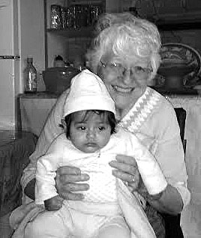
It’s that time again…to catch you all up on Huayapam doings. The family of Tia Julia showed up one evening to help me celebrate my birthday. They brought bread to eat with coffee and the ever popular gelatin dessert that usually shows up on birthdays. We have developed a relationship with the whole family because we bring communion on Sundays and Liz has treated all of them for many health issues; soon it will be in the very therapy rooms! His little grandmother loves big hugs…me too and we both look forward to exchanging them.
I’m including an older photo of our God-daughter Xochitl Iyari. We see them quite often. The ice cream photo on top is a more recent one of the family except Nancy who goes to school on Saturdays. I’m holding Pat’s cone while he takes the picture
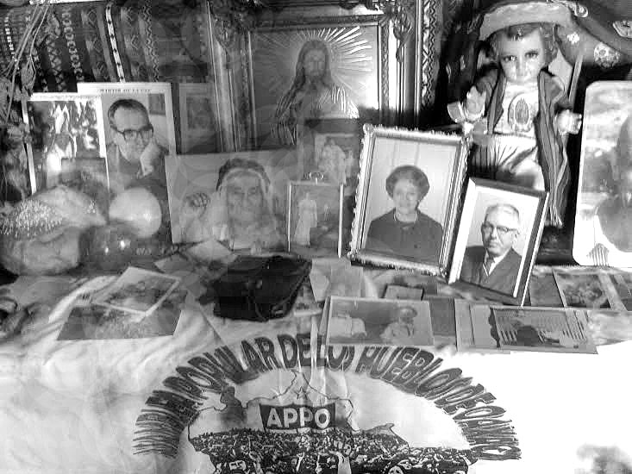
My ministry of bringing communion to the people who are old and/or ill is an ever ending source of delight and grace for me. I also got elected by our small group of pastoral workers to be in charge of the lay pastoral work in our community. In the parish, we are 6 communities. Father Juan Antonio is the pastor for all 6 which keeps him hopping. There are many meetings at each level of the church to try to keep things on track…it’s really like herding cats but I try to show up and be somewhat useful. I am thinking of all of you and your loved ones as we celebrate these Days of the Dead, a remembrance of those who have walked on. Here in this culture we are always aware of their presence, especially now. I invite all my ancestors to come and celebrate with those from here. We have photos on the special altar. Not too fancy this year but with fruit and drink so all know they are welcome.

Janet Hockman, MM ’86 November 15th LaTrembly, Haiti
Good Morning again from the land of mountains behind mountains. It has been another week of learning and amazement. I continue to go to the little school next door for English classes with grades 3, 4, 5 and 6. I am rather sure the alertness of observation is well and mutually matched! Quick snatches to touch my soft and light-skinned flesh continue to take me by surprise. Yesterday a 6th grade boy at LaFoyer School wanted to know the word for the water dripping down my face…sweat. (Do I dare tell you that as so many of you are wrapped in winter?) I prepared a very simple craft project for the 5th grade yesterday. I put small amounts of white glue on leaves. As they finished their flowers, I noticed some of the students very quietly taking the leaf off to other parts of the room – they were repairing their torn books. I was touched with their care of something important to them.
Last Wednesday Sisters Dianne (Charity) and Susan (Maryknoll) and I visited a foundation that began many years ago with a school and orphanage and now is a larger school, clinic, adult skill training center. After the earthquake, they had live-in camps for women amputees who needed to adapt to their new physical situation. It is quite an amazing place, serving about 20,000 people in nearby villages. The founder, Lucianne Duncan, is now in her 80’s. The first thing she built and offered was a chapel/church for the people of the area. Evolution of services is evident; isolation of no one is important to them, including working with a voodoo doctor to expand his knowledge of other forms of healing. The road there was also an experience. Hurricane Sandy washed away the road, or rather carved it deeper. The present ‘road’ is now almost 5 feet directly below the old one. The excavation done by forceful waters is below the foundation level of some buildings.
Last Saturday morning Prophet came to the gate. He now has his passport and a visa to go to Brazil but still saving for his ticket. He has a sister there and is certain he can find work. Prophet did some work at the house here and the sisters gave him some financial help for his trip. His visit last Saturday was of thanks with banana plants, seedlings of papaya trees, eggplant, and an orange tree. He went to the garden in the back of the house, took off his shoes and began planting. I pulled weeds beside him so quietly and humbled. What a way to depart…leaves something behind to grow. He may have no land of his own here, I do not know, but what a missioner’s lot to be entrusted with life and potential growth. It was his thanksgiving gesture. What is mine and yours at this time?
Know I have you here in my heart and ask God's special blessings for you, too. Janet

Janet Hockman, MM ’86 November 23rd Latrembly, Haiti
Hello again to you all. A week ago I was back in Cuvier walking with Nikano as he was doing another portion of a simple compound and house to house survey. It was a holiday here in Haiti so many people were around, especially children. Nikano had to translate for me and laughed at the things asked. He laughed hardest when one girl, holding my arm, looked up at me and asked, “what do you eat?” So many questions I would have liked to ask, too.
Yesterday I was back in Cuvier for the women’s group with Susan. Blendina came into the circle of rough benches and pulled out three of the head-band/hats like the ones we made the week before. She made them herself during the week! Motivation. The women of this group are all single heads-of-households. They are just a few of so many. While the women were working on their projects, I could hear little kids in the background. They were inside the church (just barely a structure) playing school. It is where they have ‘pre-school’ during the week. One of the little girls stood at the brown board pointing to letters with a stick while the other little ones repeated. It was a wonderful, eager scene and so full of hope. Affording to go to school is a huge drawback though.
I had my first trip through the Croix des Bouquet market. Our mission was to buy sewing supplies for the women’s group. It was a step into every-day realty for people here, paying for a little space to sit and rest their fruits or vegetables or chickens or charcoal to sell …or anything else imaginable. There is quite an art of arranging articles for display in baskets or wire frames of an old fan or a cardboard box or a make-shift wheelbarrow. Bargaining, Banter, blank-looking faces, weariness, hope… all along muddy passages appearing way too narrow for the vehicles that do make their way. At an intersection, a man stood with a large old cassette player --- loud music and dancing. Others joined in singing as they walked by. Smiles erupted. I’m promised a trip to the goat market in two weeks for the purchase of 12 or so goats for a self-sustaining (or so intended) project Dianne, the Charity sister, has lined up for other women from the village. If it works, she will receive a goat from the first births from each goat initially given. I doubt that she ever dreamt of being a herdswoman herself.
Oh, I can add to the morning sounds I mentioned before, and that is the horn, like the black rubber ball bicycle kind, announcing a man selling ice along the road. Did I mention that the sort-of-paved road is a main one into the Dominican Republic? It’s the endless paths through fields and up mountains that I ponder where they lead…
So this is Thanksgiving week in the USA. What roads will you travel? Where will you shop and with whom will you take time for bantering? What sounds of life will you be attentive to? And with whom will you gather? I pray for attentiveness to all and surely gratitude will flow.
Again I want to say how grateful I am to all of you who love me, who question why I do what I do, who support me in all kinds of ways, who engage me with what is important in their life, who hold me in prayer. Thanks for trusting me enough to be eyes and ears and heart of connection to life here and there and bring all to the heart of God. With love, blessings, gratitude. Janet
December 8th
Since yesterday was Sunday, I’ll tell you a little about my experiences of ‘church’ here. We went to mass in Croix de Bouquet. At every entrance people were begging, their belongings piled or rolled nearby. Markets surround the church, with all the noise and activity and smells of open markets. Since I am at a language disadvantage anyway, it was easy for me ‘drift’. A huge distraction this morning was a Mack truck making its way through the market, a feat I thought utterly impossible. I held my breath (Big Mac will always mean Big Mack to me now!) In each of the 4 catholic churches I’ve been to, I’ve noticed the silk flowers covered with clear plastic; by now I understand it is an effort to keep off some dust. Sound systems never seem to work. Last week the choir director connected and disconnected simple wires according to which microphone was needed. Yesterday the green, red and white lights over the Blessed Mother’s statue lit if the power was on. People are so nicely dressed when they go to church. I’ve knit my eyebrows about this a few times after seeing village homes. The ‘good’ shoes especially puzzled me – how is it possible to walk through mud and dust and have them so clean? Last week, though, I saw women gathered by a trickle of water across the road from the church washing their feet and legs then pulling out church shoes from their bags. They planned ahead! The music is wonderful and, even though I do not know the words, the rhythms seem to touch my soul. So, churches are not quiet and peaceful places for me here but they are reflective. Who are all the people gathered? What has their life been? How is it I was born where I was and into the life and family I was born into? Mystery all! And I keep aware that God is here.
Speaking of music, I saw a great drum set on the side of house. The large drums were up-side down cans; the cymbals the lids of the cans teetering on sticks. A little three year old girl spent so much energy singing, dancing and playing those drums! What a joy to experience her. There is also music coming from all the schools and churches as they practice Christmas music, many familiar tunes.
I decided to do a Christmas type craft with each of my classes. I wish I had planned ahead and brought some simple materials with me. It is almost impossible to even find scrap paper. I bought some glue at a hardware store in town weeks ago but when we tried to go to the same store again, the road was closed while a drain pipe is being put in. Susan and I went to the market to look for glue, thread, elastic and sisal (rope). We came back with bananas and onions. So this is what we managed in the craft department: beads made of magazine pages; checkerboards from old cardboard boxes with the ‘board’ being pre-cut squares of red tissue paper and white squares from the pages from an out-dated This Is the Day; Christmas trees and wreaths also from the cardboard boxes and tissue paper. This week’s project for the women’s group was heart ornaments from sisal. It was fun to catch the ‘drift’ of their conversations about where in Haiti the sisal is made, how much it costs in the market and if they make them on their own this week and I ‘buy’ them at 2 for 5 gourdes what their prophet would be. Four more classes to prepare and lots of adaptations but worth it all with how proud the crafters are with their pieces. That glue got watered down pretty well. I really appreciate someone telling me almost two years ago that ‘everything you need, you have’. I have to remember to keep looking and re-imagining.
If my hair could get any more grey it would surely be from experiences of traffic on and off the road and mud ruts and sidewalks and I try to imagine myself driving and know I am a coward. One does not need to know parallel parking for roads here but for up on the curbs! Maybe a helicopter would be a better option? Or a donkey? I am not sure walking is very safe either.
The banana trees are growing well, papaya seeds I planted my first week here are 5 inches high, beans took three days to sprout and pepper plants are shyly peeking through. I go every morning to see if there are flowers on the squash vines (some critter usually feasts on them pre-bloom). I just can get so engrossed watching bees pollinate the flowers on the loofah vines. Today I was almost just as amazed at bees drinking from the water while I was doing my laundry.
I not know the names of the children where I spend my mornings. Not catching new sounds keeps me aware of how different English sounds are to them. But there is facial recognition and a lot of eye contact, curious, amused, questioning, confused, funny, delighted. I miss the ones who are absent and catch the ones trying to change their seats. And there are those who have endeared themselves unknowingly and those in whom I recognize real eagerness. A 14 year old boy in 4th grade keeps bringing someone else’s books to ask questions. Today I mentioned a country and he pulled out an old geography book and looked for a world map. Another girl does not come anymore, not inside the classroom. She peeks in the window from outside where she works with her mother to cook for the students. Her tuition isn’t paid. Last Friday one school principal asked us to help pay teacher salaries; today another teacher asked the same. Saying ‘no’ does not come easily; a concept of offering time does not buy food. There are endless needs and endless wants, too. It takes time for relationships to develop and to know how I/we are perceived and what expectations are held. I have just a few weeks left to be here this time. It has been gift, awakening, mystery, questioning, hopeful.
In this Advent time, the community here gathers each evening in prayer. Sometimes Pierre, a night watchman, sits 15 feet from us reading aloud from the bible or singing, sometimes people in the protestant church on the roadside of the house are singing, or people are praying at another (unfinished) Christian church a ¼ of a mile down the road. Life enters into prayer. May my remembrances in prayer touch the lives of those I love and care for, too. The readings of waiting and watching and longing speak so much of change and how our world needs changes toward justice and peace! May your preparations for Christmas be with special attention and love and peace, too. Janet
Angela Bianco, S.L. ’62 (Darius) December 6th Yorktown Heights, New York
Tales from a Journey With the Navajo People (from a future e-book in process)
I spent 14 years working and living with the Navajo people on the southwestern edge of the reservation, about 100 miles due east of Albuquerque, NM. The area is characterized as high plains desert, with a short rainy season in mid-summer & many days of bright sunshine, even after a heavy snow.
Initially, I worked as a volunteer at a Catholic Mission, and created outreach programs aimed at offering needed services to local families. The Mission also created a school for anyone interested in a catholic education. Teachers were volunteers, and I was asked to coordinate the school meals as well as meals for the outreach programs we offered.
Acquiring food (via food banks, USDA surplus supplies, and local donations) was a daily challenge, and cooking was no small task. The kitchen staff of three cooked for our Meals On Wheels, offered breakfast for the local men’s shelter, breakfast and lunch for the children, meals for the 20 volunteers and staff, and “real Italian pizza” for Thursday Bingo nights.
One day, the Director, Father Doug, asked if I would please pick up a ‘donation’ offered to us by a local farmer who raised pigs, had several new broods of piglets, and offered three for us to raise and later use for food. We knew that feeding the piglets left-over’s from uneaten meals would be economical, and we had an offer of corn to use as feed.
That evening, two of us set out with the mission truck to pick up the piglets. The farmer gave us a tour of the buildings where the pigs were raised, and encouraged us to pick out 3 ‘we liked’. Being born and raised in Brooklyn, NY had not offered an opportunity to judge quality regarding piglets, so we just picked the cutest, and watched as the farmer placed each squealing wiggly piglet in a burlap sack, secured it with baling wire, and placed them in the truck bed.
Since it was a rainy evening, we decided to take the access road to the Interstate & drove to the Mission, noticing that on-coming vehicles would ‘blink’ their lights as we approached. We weren’t sure of the reason, but watched the road for possible hazards. When we reached the Mission, Father Doug and several others came to see the pigs and help transfer them into the newly made stalls that would become their home. But, when we looked in the truck bed, there were two squealing, squirming sacks, and one open, empty one. So, the reason for the blinking lights from on-coming cars became obvious!
The two pigs were placed in their stalls, fed and made comfortable for the night. We searched the immediate grounds for the missing piglet, but I was pretty sure he (or she) had ‘jumped ship’ after the gunny sack had opened. That night, (and many more) I heard the piglets from my window since the stalls were close to my trailer.
The next morning, after hearing of our mishap, the farmer encouraged us to come and get another piglet to complete our trio.
Another journey in the truck was accomplished, but this time the piglet was secured in a gunny sack, baling wire used to secure it, and I placed the wriggling one inside a spare tire, and inverted a metal milk box atop that, which I also secured. This piglet was coming back all the way with me!!
We made it home, and Father Doug had announced to the school children that there would be a ‘naming contest’ with prizes for the three best names for our new arrivals. After a week, with some very original submissions, the winning names were announced, but the prize was not awarded, since Father Doug’s entry was judged the best…and so CURLY, MOE and LARRY lived out their days at the Mission until they became wonderful roasted pigs that were enjoyed by all…
.
When a woman says “What?” it is not because she did not hear you.
She is giving you a chance to change what you said.
FAVORITE RECIPES
Jerry Hardiman (esposo of Ro Brady Hardiman) Bethany Beach, Delaware
Let’s say you have some ground beef in the refrigerator and some onions, potatoes and carrots on hand. Well, you’re in good shape for preparing a number of quick and satisfying winter meals: always comforting meatloaf; a variety of tasty burgers; and this easy Shepherd’s Pie.

Shepherd’s Pie
Ingredients
1 pound lean ground beef
2-3 cups mashed potatoes (smooth enough to spread on top of meat mixture)
½ onion chopped
1 teaspoon minced garlic
1 cup sliced carrots (precooked)
1 cup beef broth
1 teaspoon Worchester sauce
1/3 cup catsup
1 tablespoon flour (we use Gold Medal Wondra quick-mixing flour)
1 teaspoon salt
¼ teaspoon pepper
½ teaspoon oregano
½ cup shredded cheddar cheese
(You can adjust quantities to suit your taste and preferences.)
Preparation Steps
- Sauté onion in skillet over medium heat, with a little light olive oil, until soft.
- Add ground beef and sauté until brown.
- Drain fat from beef/onion mixture. (We spoon off most fat and then put the mixture into a mixing bowl lined with paper towels. It’s then close to fat-free.)
- Return mixture to skillet. Add and stir in garlic, cooked sliced carrots, beef broth, Worchester sauce, catsup, flour, salt, pepper & oregano. (We sometimes also add a little extra cheddar cheese.)
- Heat mixture in skillet over low to medium heat about five minutes, stirring occasionally, until mixture is slightly thickened by the flour.
- Spray baking dish (we use a 10-inch glass pie dish) with non-stick spray.
- Spoon meat mix into baking dish. Spread mashed potatoes over top & sprinkle with cheddar cheese.
- Bake uncovered at 350 degrees for about 30 minutes.
- Serve with vegetables of choice. (String beans go well.)
- Guinness also goes very well with this dish—both during preparation as well as with enjoyment of the meal.

If you prefer chicken and happen to have some chicken breasts on hand, here’s a quick recipe we enjoyed at a neighbor’s recently. Hope you enjoy this too.

Dijon Chicken Breasts
Preparation Steps
- Lightly coat chicken on both sides with Dijon mustard.
- Dredge both sides in Panko bread crumbs.
- Spray baking dish with non-stick spray and arrange chicken in dish.
- Bake, covered, at 350 degrees for 25-30 minutes.

Switching gears to mental health, here’s some food for thought. Do you have pronoia? I learned from a Dan Ariely column in the Wall Street Journal in October, crediting Wharton Professor Adam Grant, that pronoia is the opposite of paranoia. Pronoia reportedly is the delusional belief that people are plotting our well-being and saying nice things about us behind our backs.
Sounds like a good attitude to me. Even if it’s delusional thinking, pronoia certainly is a happy, cheerful mind-set, especially if you’re wondering what people think about your cooking. Coincidentally, that thought was recently reinforced by a reading at Mass with the paraphrased assurance from Psalm 23 that “only goodness and kindness will follow me all the days of my life.” So when we enjoy those pronoia feelings, we’re in good company.

“Vegetarian” is old Native American word for bad hunter.

KATERI’S CORNER
Keeping the thermostat too low could increase the risk of falls in older women. A new European study published in Age and Ageing found that just 45 minutes of exposure to chilly room temperatures caused stiff muscles and impaired walking. Researchers tested healthy women ages 70 to 95 in a 59-degree room and a 77-degree room. The women in the colder room did worse on almost all performance tests, except for hand-grip strength. So it’s a good idea to turn up the heat. AARP, December 2004 p 11.

TRANSITIONS
Unless otherwise noted, the following are adapted from Letters of Appreciation written by
Members of the Maryknoll Sisters. Edited by: Rosemary Brady Hardiman ’63

Anne R. Roarty Biggins ’63 (Marian Daniel) d. 10/6/2014
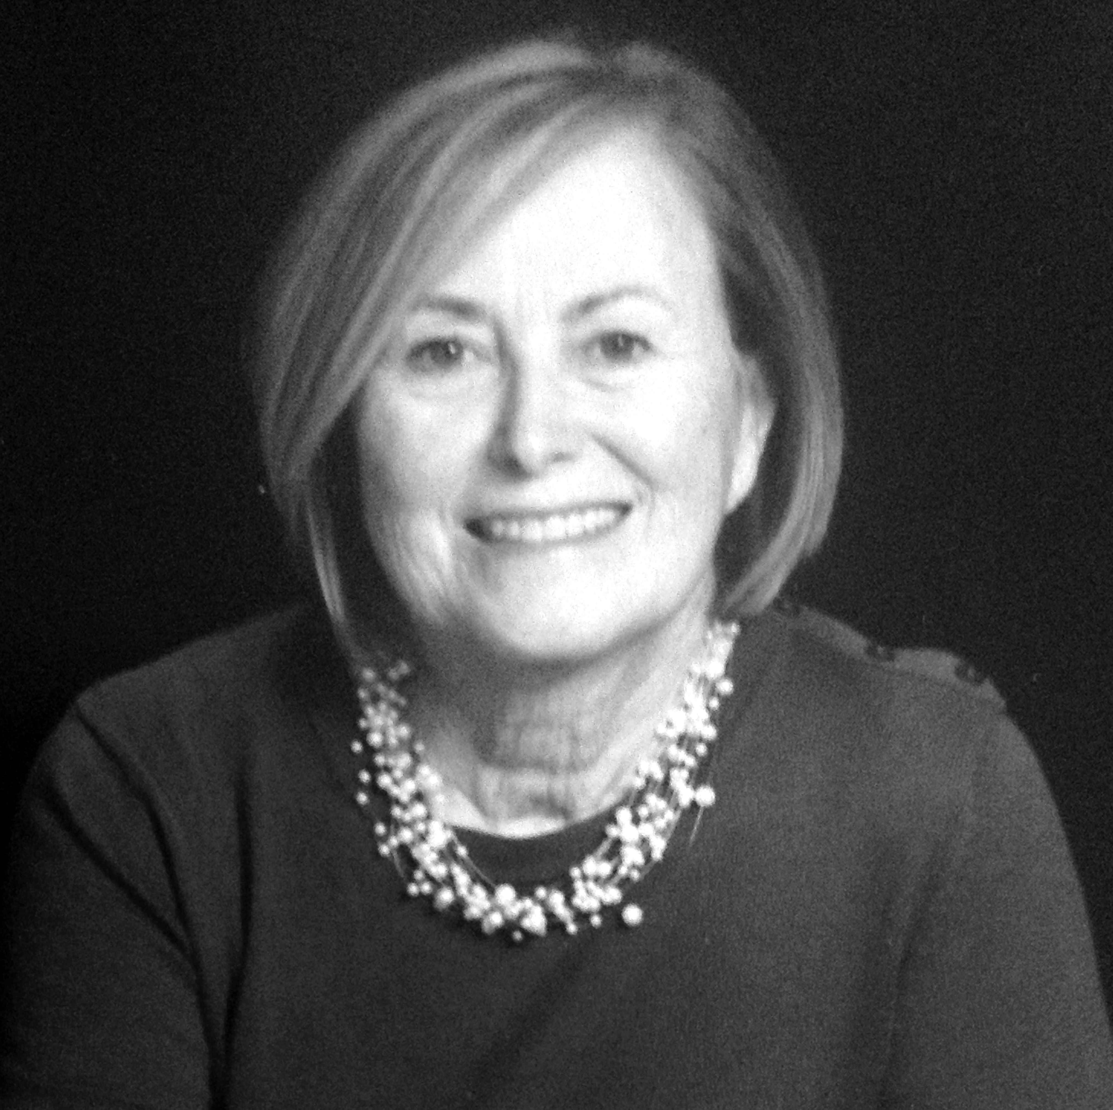
[Ed. Note: By Sarah Biggins Kelzenberg ’63 (Sarah Peter), Anne’s sister-in-law, with help from Jim Biggins, Anne’s husband & Sarah’s brother.]
Anne was born in Kingston, PA on 11/4/1944, but spent most of her childhood years in Chevy Chase, MD. After graduating from Ursuline Academy and attending Dunbarton College and Mary Rogers College, she graduated from the University of Maryland with a B.A. and M.A. in Speech Pathology in 1969. That same year she married James Biggins, an officer in the U.S. Navy. She accompanied him on many tours of duty while they gave birth to and nurtured three wonderful boys: David, Dan and Timothy.
Jim & Anne’s boys are all married and they have five brilliant grandchildren (Katie, James, Greta, Sam and Teddy Biggins) who keep their parents busy. They all live in the New York-DC corridor. This closeness has meant a lot to Anne and Jim, especially the last couple of years.
While the kids were young and the family moved every two to three years, Anne professionally worked as a speech-language pathologist in Head Start and various schools, K-12. Upon moving to the DC Area, Anne became a Speech-Language Clinician for Fairfax County, working with students in elementary trans-disciplinary programs for speech and language, learning disabilities, moderate-severe disabilities, emotional disabilities and autism. Anne then took a position as a Communications Disorders Specialist in the District of Columbia, monitoring the speech and language program for more than 3000 students, Preschool-12. Anne finally became a Special Education Program Monitor, monitoring all special education programs, preschool through grade 12 in two high schools, two middle schools and 10 elementary schools. While doing this challenging work, Anne was also an independent consultant for Harcourt Brace School Publisher, reviewing textbook manuscripts and an Adjunct Instructor at George Washington University, George Mason University, and Marymount University.
In 2001, Anne began working full time at George Washington University as a visiting Instructor and directing a Professional Development School for master’s degree candidates. Anne ended her time at George Washington University as an Assistant Professorial Lecturer in Special Education.
After a number of years living in the District of Columbia, Jim & Anne retired to their home in Lusby, MD, and had plenty of space in their home for kids and grandkids. In addition to gardening, boating, etc., they were involved in various support programs in their parish, Our Lady Star of the Sea, Solomons, MD. Additionally, they were both active in the local Habitat for Humanity.
After a two-year struggle with lung cancer (Anne never smoked), with Jim at her side at every turn, Anne accepted that it was time to pass on to our Father in heaven. She leaves her sisters, Mollie McMahon and Karen Roarty-Dansfield and her brother Joseph Roarty. She also leaves her in-laws Emily Williams, Peter Biggins, Sarah Biggins Kelzenberg and William Biggins. In her passing, we all are grateful for the multitude of moments that we enjoyed with Annie. We know that she will always be in our hearts and memories with her quick wit and joy-filled spirit. [Ed. Note: Messages of condolence may be sent to Anne’s husband, Jim Biggins, 309 Deer Drive, Lusby, MD 20657.]

Rosalie Isabelle Rienzo Rogers,’55 (Maria Lourdes) Castro Valley, CA
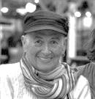
Rosalie Isabelle Rogers Rienzo died peacefully at home on December 15, 2014, after a courageous three-year battle with cancer, surrounded by family and friends. A prayer service was held the next morning over-looking San Francisco Bay, which she loved.
Rosalie was born in Torrance, CA but spent her childhood in Arequipa, Peru, returning to California in ‘48 to complete elementary school and high school in Oakland. She continued her education for one year at Holy Names College and then entered at Valley Park in ‘55. In 1964, she earned a Master's degree in Spanish American literature at St. Louis University, St. Louis, MO.
Rosalie is survived by her husband of forty-four years, Gregory Rienzo, one daughter Jenny Rienzo Chairez, Jenny’s partner, Ana, and two grandchildren. In addition, she is survived by four siblings, Ralph, Marjorie, James and Allen, nine sisters and brothers-in-law, and many cousins, nieces and nephews in different parts of the United States, Europe and South America.
Rosalie was a teacher and social worker for fifty years. She taught in Harlem, 100th Street in the '60s, at the Motherhouse in Westchester, NY, at the University of San Marcos and the Catholic University in Lima, Peru, and in the Andes at the Azangaro Teacher’s College. Her duties included being a university campus minister where a colleague was her future husband.
After marriage in 1970 at the Newman Chapel at UC Davis, Davis, CA, Rosalie taught school in Chicago, New Orleans, California, as well as in neighboring counties with the Migrant Education Student Program. For the past 20 years, Rosalie taught with the Oakland Unified School District where Kindergarten was her specialty. Rosalie also taught with the Castro Valley and the New Haven Unified School Districts. In Merced she served as state-appointed ombudsman for senior care facilities, was a founding member of the Merced-Somoto, Nicaragua Sister-City Committee and Mujeres Latinas, and was an ardent advocate for women's and farm worker rights.
In later years Rosalie was a member of AAUW, Friends of Sabeel-North America, PFLAG & the Justice & Peace Ministry of All Saints Parish where she co-founded God's Rainbow, a support group for Gay/Lesbian Catholics and their families.
Rosalie was known and loved as a joyful, celebratory, fearless person who loved life and people, flowers, music, dancing, and the ocean. Her large extended family and many friends were included in her loving embrace. It has already been said that she danced her way into Eternal Life.

Margaret Kulage, M.M. ’29 (Mary Irma Francis) d. 8/28/2014
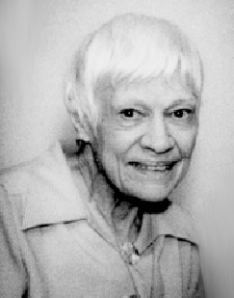
Marge Kulage was born on 6/24/1907, in St. Louis, MO. Her nine siblings have all predeceased her. Sr. Marge’s wonderful, long and graced life spanned 107 years, winning her the accolade of being the eldest ever Maryknoll Sister!
Following graduation from Holy Cross Parochial School, Marge attended Speedwa Business School for two years and then worked eight years for the Shell Oil Company in order to help her family financially.
Margaret entered Maryknoll on 4/5/1929. She made her First Vows at the Motherhouse on 6/24/1931 and her Final Vows on the same day in 1934.
Sr. Margaret completed her high school education at the Venard at Clarks Summit, PA and studied music at Pius X School of Liturgical Music in Manhattan. She completed work for her Bachelor of Education degree from Maryknoll Teachers College in 1958, while serving also as assistant Superior at St. Teresa’s Convent, the residence for Sisters working in the Maryknoll Fathers’ offices.

Sr. Marge was assigned to Hawaii in 1943 where she engaged in catechetics, pastoral work and education on Oahu and in Kalihi. Recalled to the Motherhouse, she served in a variety of administrative works, including Mistress for Junior Professed Sisters. Returning to Hawaii in 1962, she served as superior and principal at St. Anthony School, Kalihi on Oahu and later taught in Wailuku, Maui (1965-66).
After two more years in administration at the Motherhouse, (1967-1969), Sr. Marge went to the Philippines where she taught at Maryknoll College, Manila, (1969-1970) then as principal of La Salette Elementary School, Santiago, Isabella, (1970-1972).
On several occasions, Sr. Marge had asked to join the Maryknoll Cloister Community. Each time she was told that her vocation was to the active life, and living the Dominican ideal of Contemplation in Action. She was a model of this ideal throughout her long life.
In 1972 Sr. Marge and 11 other Maryknoll Sisters in the Philippines survived an ordeal which had a lasting effect on her life. After their boat capsized, they survived 16 hours in shark-infested waters off the east coast of Mindanao. This same year, Sr. Marge’s missionary life took an entirely different turn when Jim Noonan, MM asked Sr. Blaise, the Regional Superior, if a Sister could serve as secretary for the Maryknoll Fathers in the Philippines. It seemed like an answer to Sr. Marge’s prayers, and she worked happily in the position until 1978.
It was while she was working for Fr. Jim that Sr. Marge discovered the ministry that would define her active missionary life: prison ministry. During Father Noonan’s absence, Sister kept in touch with some of his prison friends. Before long she came, “to the discovery that residents in jail are among the poorest of the poor in so many ways, and also that few people are willing to show compassion for them. Prison is People,” she wrote, “real people—they are not just case numbers. Many in jail do not deserve to be there; and many walking the streets do deserve to be in Jail” Before long, she found herself visiting jail residents on a regular basis whenever time permitted. Sometimes, her age proved an asset in speaking with officials, attorneys and judges. And indeed, it did as she managed after tenacious effort with officials to free a prisoner serving time for a crime he did not commit! For her prison work, Sr. Marge was awarded the Everlasting Award on the occasion of the Benguet Foundation Day celebration in 1981, in recognition of her deep concern for the welfare of the provincial prisoners through spiritual and maternal assistance.
In 1984, The Metro Manila Metropolitan Police Force in Quezon City, singled her out for an award which reads: “in fitting recognition for her outstanding contribution to humanity with genuine sense of sincerity & compassion, manifested by her philanthropic deeds & dedication to the cause of the poor, the sick and the needy, a noble virtue of a true Christian heart and God’s special gift to mankind.” She continued her apostolate in the Quezon City Jail & later in New Bilibid Prison, the National Penitentiary of the Philippines, in Muntinglupa, Manila. In 1997, she received the Award for service, presented by the Episcopal Commission on Prisoners’ Welfare, of the Catholic Bishops Conference of the Philippines.
Sr. Marge also engaged in the charismatic movement in the Philippines. She organized prayer groups with lay people, teachers, doctors and nurses, and Bible Study classes to help them “learn how they can personally apply God’s Word to their everyday lives.”
At 88, Marge began to realize that she was growing old, but she did not want these last years to be wasted. She wrote, “I feel the time is near when prayer and sharing in the redemptive sufferings of Christ may be my greatest contribution to the mission cause.” She was not quite ready to give up. She added “At the same time, with the help of therapy I envision maybe years of helping part-time where I can.” Someone once commented, “Marge is the busiest retired person I have ever known.” During her retirement, Marge had taken the Philippines and Prisons for her Prayer Ministry.
Ever thoughtful, Marge left a word of thanks for all those who would care for her in her final illness.
Nearing her 90th year, Marge verbalized her thoughts on death. She wrote, “Affirmation of life, now and forever in the Presence of God” in which she marveled at “the ineffable, incomprehensible mystery of God’s LOVE relationship. I look forward to the day when I will no longer be here, but rather will have arrived so close to God’s home, Abba will invite me to come inside and stay forever — the better to experience and appreciate the mystery of God’s great Love relationship.”
And so we lay to rest in the hands of the one she preferred to call Abba, a remarkable woman, a courageous, sensitive, intelligent woman, whose sense of a kindly humor made her such a delight to know and be with. Betty Ann Maheu, M.M., Community Member.

Helen Louise Gleason, MM ’48 (Evelyn John) d. 9/11/2014
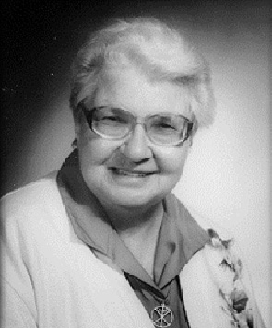
Helen was born in Cloquet, MN on 1/20/1929, the sixth of eleven children. Her parents and four brothers predeceased her. Helen’s mother, Exilia, was a descendant of Jean Nicolet, an explorer of Lake Michigan and Louis Joliet who explored the Mississippi River, a fact that Helen enjoyed sharing and which added understanding of her joy while serving the Ojibwa people.
Helen graduated from Cloquet Public High School in 1947 and entered Maryknoll at Valley Park, MO, on 10/14/1948. She made her First Profession of Vows on 5/8/1951 at Valley Park & three years later made her Final Vows at Maryknoll, NY. Sr. Helen graduated from Maryknoll Teacher's College with a Bachelor of Education in 1956.
Her first mission was to Kalihi, Oahu, HI, in 1956. She served in Hawaii from 1956-1974 as a primary Grade teacher in seven different parish schools.
From 1975 to 1980 she served in Majuro, Marshall Islands and returned to serve in Hawaii until 1991. At that time she volunteered for mission work in Papua, New Guinea with Srs. Pat Redmond and Peggy Dawson. Sr. Helen had a gift for teaching kindergarten and primary grades. She initiated a much-needed pre-school program for the rural area. During her retirement Sr. Helen took Papua New Guinea for her prayer ministry.
In July 1995 Sr. Helen returned to the Center to give service and in July 1999 Srs. Helen and Ann Maloney volunteered at St. Mary’s Mission in Red Lake, MN, on the Red Lake Reservation for the Ojibwa people. While there, they were asked if they would consider being a “presence of the Church” on the Fond du Lac Reservation in Cloquet, MN which was without a pastor. In June 2000, Srs. Helen and Ann moved into the former Holy Family Rectory on the Reservation. In the fall of 2000 Srs. Claire Murphy and Pat Ann Arathusiak joined them, helping in the parish while Helen continued her work preparing children for their First Holy Communion and visiting other parishes on the Reservation. In 2007 Sr. Helen went to Monrovia, CA, to retire.
Early in 2010 a call came again from Cloquet to help with the catechetical programs in the parish. Srs. Helen and Peggy Dawson went to Cloquet for two years. In 2012 they felt that they had contributed as much as they were able to the parish and retired to Maryknoll, NY.
Helen was a very quiet person who loved to read, was known for her smile, and quiet, happy disposition. In her silence she was a positive presence, which was felt with her great gift of pun making, sending everyone into rolling laughter.
Helen was very fond of her family &she wrote the following about her family & mission: “It has been so good to be back with family & friends in Cloquet & with my much loved Ojibwa people. I have enjoyed all my missions. Each culture brings new insights and glimpses of a loving caring God in the faces and spirits of the vast human family of ours—and new ties and relationships to the Universal Church. What a blessed & humbling life is that of a missioner.” Condolence messages may be sent to her sister Irene Polley: Mr. & Mrs. Edward Polley, 826 Birch Street, Cloquet, MN 55720. Sr. Rose Lauren Earl, MM

Bernardine Remedios, MM (Carmen Fernanda) ’56 d. 10/17/2014
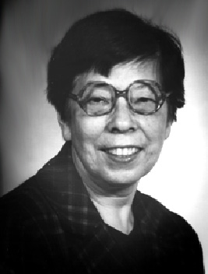
Bernardine was born 8/25/1930 in Kowloon, Hong Kong. She is survived by her five brothers and one sister. Bernardine entered Maryknoll on 9/2/1956 at Maryknoll, New York. She made her first Vows on 6/24/1959 at Maryknoll, NY & her final Vows in Hong Kong on 6/24/1965. Sr. Bernie, a faithful and essential member of the Fr. Cotta Group, was 84 years old and a Maryknoll Sister for 58 years.
Our remembrances of Sr. Bernie are many. Her laughter and sense of humor engaged all of us and her heightened sense of responsibility impressed those who knew her and worked with her. Some little known facts that are important to know about Sr. Bernie are that she was the Badminton Champion of Hong Kong; an avid bridge player and loved tennis (watching it that is!). She loved to gamble—her own money of course, and got pleasure out of winning. Sr. Bernie, in her clipped British accent, loved to get into philosophical discussions and was constantly searching and asking “What do you think?” God has been waiting 84 years to answer this question for her.
Sr. Bernie’s first assignment was to Taiwan from December 1960 to 1969 and her various ministries included: Pastoral work, youth ministry, work with students and factory workers. She responded to the opportunity for ongoing education and graduated with a Bachelor of Science in Education in 1972 from Mary Rogers College. After assisting in the Sisters’ Treasury Department for two years, Sr. Bernie became the Director of the kindergarten in Chinatown, NY. Sr. Bernie eventually returned to Taiwan and Hong Kong, assisting the Regions as Regional Finance Director.

In 1987, the Congregational Leadership Team asked Sr. Bernie to return as Assistant to the Treasurer of the Congregation and in 1993 Sr. Bernie was appointed to the position of Congregational Treasurer. She continued in this position until her retirement in 2001. She then rejoiced in her assignment to Monrovia, CA.
In a letter from then President Sr. Helene O’ Sullivan, dated 1/1/2001, when Bernie completed her term as Congregational Treasurer, she wrote: “You have been a wonderful steward of the resources of the Congregation which has enabled us to continue to be effective in mission around the world. You have put in long hours each day for years in the service of your Sisters and Mission and we are deeply grateful to you! We are in good financial shape thanks to your devoted and competent work. It has been great working with you.”
Sr. Bernie requested to go to Chandler, AZ from 2009-2010 with Sr. Bridget Chapman. This gave her the opportunity to live a more quiet and contemplative life such as she had attempted once before in a House of Prayer on the island of Lantau. Her desire for quiet and prayer was dominant in her life.
Sr. Bernie’s wrote to Sr. Regina Pellicore when accepting her position, saying: “It is a challenging task... …I myself feel it is a privilege to be asked to do this work. So I say, YES.”
This is the hallmark of Sr. Bernie’s life! May we all strive to remember her by saying our own “YES.”
Sr. Bernie is survived by five brothers: Dr. Alphonso Remedios in So. Dakota; three brothers in Australia: Carlos, Eduardo, Fernando; one brother Philip in Hong Kong and a sister, Therese in Canada. Messages of condolence may be sent to her sister Therese: Mr. & Mrs. Leo Wiegers, 581 101st Street, North Battleford, Saskatchewan, Canada S9A 0Y5. Sr. Marion Puszcz, MM with Members of the Father Cotta Group 1956.

Elinor Loretta Doherty MM ’47 (Rose Andrew) d. 11/24/2014
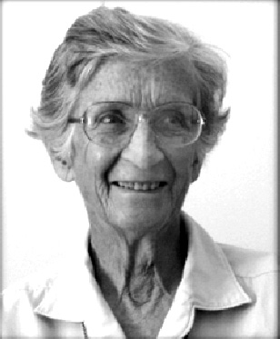
One of seven children, Elinor was born on 10/12/1925 in Pontiac, Michigan. She graduated Cum laude in l947 from Marygrove College with a Bachelor of Science in Chemistry and entered Maryknoll at Valley Park on 10/30/1947. Sr. Elinor made her First Profession of Vows on 5/8/1950 at Valley Park and Final Vows on the same date in 1953 also at Valley Park.
In 1950, Sr. Elinor was assigned to the Motherhouse as Assistant to the Postulant Mistress and two years later was assigned to the same position in the Valley Park Novitiate. In l953 Sr. Elinor was missioned to Merida, Yucatan, Mexico to serve as an assistant in a Mexican Sisters Novitiate.
In 1958 she was assigned to Guatemala City where she taught Mathematics and Science in Colegio Monte Maria, the Maryknoll Sisters School. From 1969 to 1991 Sr. Elinor was Coordinator of the Junior High Section of the School in addition to teaching Mathematics and Religion Classes. As Coordinator much of her time was given to counseling the students which endeared her to the young women. Besides her school responsibilities she managed to serve as Regional Governing Board Member from 1977 to 1979.
In 1992 Sr. Elinor chose to give service at the Center as Telephone Reception Supervisor. She returned to Colegio Monte Maria in 1995 where she remained until 2002. During these years her close relationships with former students and Alumnae served to promote the gradual turnover of the school into the capable hands of its dedicated graduates.
In 2002 Sr. Elinor was assigned to the Center House Community in New York where she used her sewing skills in the Residents’ Clothing Department. Because of her declining health Sister was assigned to the Eden Community in 2007. Naturally she chose Guatemala as her preferred prayer ministry.
Sr. Elinor was a cheerful, gentle, generous, person of quiet strength. She was a joy to know, a gift to live with and a pleasure to work for.
She is survived by her sisters Mrs. Jane Stack, and Mrs. Esther McInnis and her brother Mr. Edmond Doherty. Messages of condolence may be sent to: Mrs. Jane Stack, 2942 Moon Lake Drive, West Bloom Field MI 48323. Maura Flaherty, MM, Community Member.

Rose Marie Franklin, MM ’44 (Rose Mariel) d. 11/23/2014
Rose Marie was born on 7/1/1926 in Oak Park, IL. After graduating from Trinity High School in River Park, IL in June, she entered Maryknoll in September 1944. Sr. Rose Marie made her first Profession of Vows on 3/7/1947 and her Final Vows on 3/7/1950, both at the Motherhouse.
In 1953 Sr. Rose Marie was assigned to Pusan, Korea when Sr. Mercy requested a secretary to help with her voluminous correspondence. Thus began a mission career that proved to be beyond Rose Marie’s wildest dreams. In Pusan she lived on a bustling compound, which, in addition to housing the famous Maryknoll Sisters Clinic, was also home for the 30 some Sisters who staffed the clinic, along with many Korean doctors, nurses and technicians. Every month long lists of Sponsors arrived from the Center and each person listed received a personal letter of thanks. Although other Sisters would help her with this huge typing task, Sr. Rose Marie did the major part of the acknowledging herself, having the Regional Superior sign the letters.
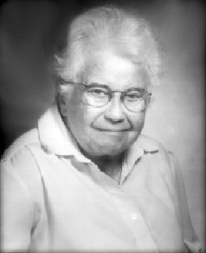
In 1964, Rose Marie was sent to Kang Hwa Island, off the west coast of Korea, where the Sisters had set up a clinic in a Maryknoll Fathers’ parish. Here, she worked in the clinic, giving support to patients and their families and making home visits. There were several textile factories in the town, which employed many young female workers who labored under very difficult conditions. To help them realize their dignity and rights, Sr. Rose Marie worked with Fr. Mike Bransfield and the other Sisters in educating the women according to the principles of the Young Christian Workers. This work incurred the wrath of the factory owners, especially when the women went on strike!
In 1971 Sr. Rose Marie enrolled in the undergraduate program at the University of Guam where she majored in Sociology. Upon graduation, she received grants at Western Michigan University for a Masters and then a Ph.D. in Sociology, which she completed in December of 1978. After graduation, she was appointed Director of Research and Planning for the Congregation. During her four years in this office, Sr. Rose Marie visited many of the Regions, helping Sisters to learn the process of Program Planning for their various ministries. She became the “Objectives, Goals and Targets” guru!
In October of 1982, Sr. Rose Marie was assigned to the Eastern Region. While living in New Jersey, she worked as the Coordinator of Development and World Order at Global Education Associates in East Orange, NJ. From 1983-1984, Sr. Rose Marie was an Interviewer for Louis Harris & Associates in Manhattan. After that, until 1990, she was Coordinator of the Peace & Discernment Program at the Intercommunity Center for Justice and Peace in NYC.
During her time at the Center, Sr. Rose Marie had the opportunity to visit North Korea as a member of a three-person ecumenical delegation. The Committee for a New Korean Policy, based in Albany, NY initiated the visit. This Committee had established relations with the Korean Society for Cultural Relations with Foreign Countries based in Pyongyang, North Korea. Sr. Rose Marie, along with a minister of the United Church of Christ and a minister from the Disciples of Christ, visited North Korea from October 9 to 19, 1984. The report, which Sr. Rose Marie wrote after the visit, reflected a more open society in North Korea than what is experienced today.
In October 1990, Sr. Rose Marie was elected to the Sisters’ Central Governing Board and served as the leadership’s General Secretary until March of 1997. In September 1997, Sr. Rose Marie returned to Korea and volunteered as a Pastoral Worker until 2002.
In ‘02, Sr. Rose Marie returned to the Center & worked in Personnel, until ‘06 when she retired. In February 2012, she was assigned to the Eden Community where she chose N.Korea for her Prayer Ministry. Sr. Rose Marie donated her body to science. Condolences may be sent to Rose Marie’s niece: Kathy & Steve Painter, 709 Timber Lane, West Chester, PA 19380-1311. Dolores Congdon, MM.

If you think you’re too small to make a difference…spend a night with a mosquito.

MARYKNOLL MISSION INSTITUTE

Program Plan for 2015

The Mission Institute will offer the following programs during 2015. Write for an application form. (Maryknoll Mission Institute, #529, Maryknoll, NY 10545-0311, tel. 914-941-7575 @ 5671 or e-mail us at missinst@mksisters.org).

May 3-8 Continuing The Mission of Jesus: Anthony J. Gittins, CSSp
(Sun. - Fri.) Discipleship Today (& Tomorrow)

May 10-15 Upstart Spring ….. Nancy Sylvester, IHM
(Sun. - Fri.) Imagine Justice….Exploration into God

May 31-Jun 5 Rethinking Catholicity in an Evolving World (REGISTRATION IS CLOSED)
(Sun. - Fri.) Ilia Delio, OSF

June 7-12 The Spirit Leads Us Forth: Mission Reconsidered
(Sun. – Fri.) Diarmuid O'Murchu, MSC

June 14-19 No Longer Servants: Toward a Biblical Theology of Friendship
(Sun. - Fri.) Laurie Brink, OP

June 21-26 The New Universe Story: God, Jesus and Prayer
(Sun. - Fri.) Michael Morwood, MA

July 5-10 Everyday Holiness: Sacred Scripture’s Teaching on Economic Life
(Sun. - Fri.) Albino Barrera, OP

July 12-17 Denial or Discipleship? Bioregional Theology and Practice in a World
(Sun. - Fri.) of Ecological Ultimatums Ched Myers, MA

July 19-24 Compassion: Witness to Love
(Sun. - Fri.) Antoinette (Nonie) Gutzler, MM

Sept. 16-19 Our Call to Personal and Global Transformation
(Wed. – Sat.) Edwina Gateley, MA Los Altos, CA

Sept. 20-25 Soul Sisters: Women Called to Connect, Bond and Heal in a Broken World

(Sun. - Fri.) Edwina Gateley, MA Monrovia, CA

ONLINE REGISTRATION IS AVAILABLE

Application forms and program descriptions may be found on our
Website http://www.maryknollsisters.org/mmi

SAVE THE DATES
Reunion: April 25, 2105
Retreat Date: April 26, 2015
(More information on page 9)

REUNION
“Women in Church
Leadership in the
21st Century”
Panel with
Betty Donnelly
Barbara Duff
Madeline Labriola Noreen Mooney

This is the 50th reunion for those who entered in 1965. Please make a special effort to join us! For those who entered in 1990, it is your 25th! A special date for you, too!
We look forward to seeing you there. Additional information and registration information will be available on our website.

We welcome submissions for publication, as well as suggestions for future articles. All submissions are subject to editing for both content and size.

FULL CIRCLE COMMITTEE
Chair Person
Ann Brown Loretan ‘59
11 Belleview Ave, Ossining, NY 10562
aloretan16@gmail.com***
Committee Members
Joan Solly Daly ‘56
Mary Gray D’Arcy ’48
Debbie Kair ‘83
Alice Lachman ‘63
Maryknoll Sisters Liaisons
Sr. Mary Grace Krieger MM ‘’48
Maryknoll Sisters Prayer Liaison
Sr. Mary Lou Andrews, M.M. ’49
Newsletter Columnists
Jerry Hardiman
Rosemary Brady Hardiman ‘63
PO Box 861 Bethany Beach, DE 19930
rbHardiman@aol.com***
Newsletter Copywriter
Terry Herman Sissons ‘58
Newsletter Editor
Karen Belinger Peterlin ‘58
798 President St, Bklyn, NY 11215
kpeterlin@yahoo.com***
Newsletter Lay Out/Photo Editor
Webmaster/Database
Virginia McEvoy ‘61
34A Apollo St, Bklyn, NY 11222
ginny.mcevoy@yahoo.com***
Secretary
Jane Cerruti Dellert ’64
Treasurer
Mef Ford ‘64
195 Harvey St. #5, Cambridge, Ma 02140
drmef@juno.com***

Full Circle Website
http://www.fullcirclemks.org
Get password from Ginny McEvoy see address above
***Please indicate “Full Circle” in subject line when emailing, as unidentified email will not be opened due to virus/scam possibilities.
Thanks

Full Circle Newsletter Subscription for 2015

That time of the year again! The Newsletter subscription is listed below. It is for the February, June and October Newsletter for the year 2015. The monies raised by the Newsletter subscriptions ($30/yr) pay not only for the Newsletter but for Website and Reunion Expenses as well. Overage provides a donation to both the Sisters and to the Chi-Rho Fund. For this reason, we are requesting these monies, even if you receive the Newsletter electronically. Please be assured that the subscription rate to the Newsletter is a suggested one. If it presents a hardship for you, we are most happy to send it to you, at a reduced rate or free of cost. No problemas. The subscription is always free for Maryknoll Sisters, Lay Missioners, & Members of Religious Communities. Please fill out the form below so we will have any changes to your address (foreign addresses are fine).
Thanks. Karen Belinger Peterlin ’58, Editor


I am enclosing $30.00 for my subscription to the Full Circle Newsletter for 2015.

Name: __________________________________________________________

Religious Name: ___________________________________________________

Year of Entrance: ___________ Phone: ________________________________

Address: ________________________________________________________

_______________________________________________________________

City ____________________________________________________________

State _______________________________ Zip ________________________

Email Address: PLEASE FILL THIS OUT - Email addresses are always changing so if you have one please give it to us even if you think we may have it.

Email Address: ____________________________________________________

Please make check out to Full Circle and send to:
Mary Elizabeth Ford
195 Harvey St. #5, Cambridge, Ma 02140
MARYKNOLL SISTERS/FULL CIRCLE
PO BOX 311
Nonprofit Org.
U. S. Postage

PAID
Maryknoll, NY
PERMIT No. 2
Nonprofit Org.
U. S. Postage

PAID
Maryknoll, NY
PERMIT No. 2
MARYKNOLL, N. Y. 10545-0311

